# **DATA DEFINITION COMMAND (DDL)**

## CREATE AND CONNECT TO NEW DATABASE

CREATE DATABASE AGODA

CONNECT TO AGODA

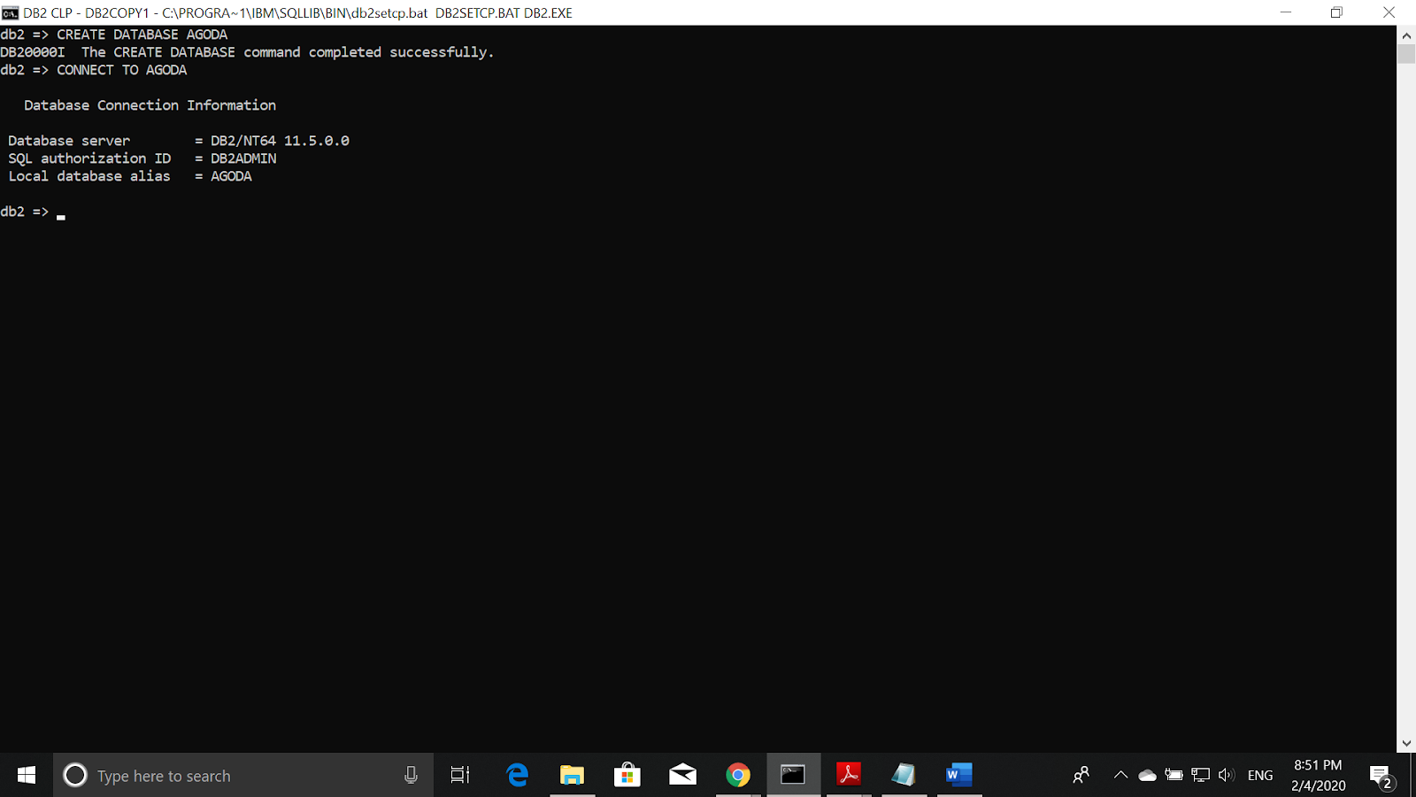

Explanation : The syntaxes above created and connected to the new database.

## CREATE TABLES

CREATE TABLE HOTEL(

HOTEL_ID VARCHAR(5) PRIMARY KEY NOT NULL,

HOTEL_NAME VARCHAR(50),

HOTEL_PHONE VARCHAR(15),

HOTEL_RATING DECIMAL(3,1),

HOTEL_BRANCH VARCHAR(20),

HOTEL_STREET VARCHAR(50),

HOTEL_POS VARCHAR(5),

HOTEL_CITY VARCHAR(20),

HOTEL_STATE VARCHAR(20)

)

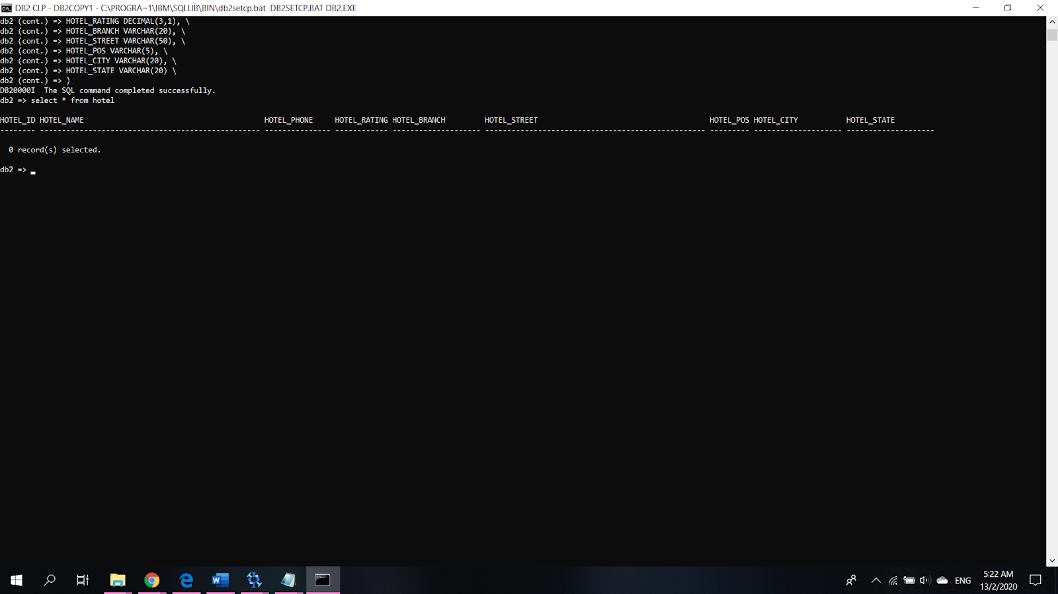

Explanation : The syntaxes above created the HOTEL table.

CREATE TABLE ROOM(

CREATE TABLE ROOM(

ROOM_ID VARCHAR(5) PRIMARY KEY NOT NULL,

ROOM_TYPE VARCHAR(50),

ROOM_STATUS VARCHAR(20) DEFAULT 'Available',

ROOM_PRICE DECIMAL(10,2),

ROOM_NUMPEO INTEGER,

ROOM_LEFT INTEGER,

HOTEL_ID VARCHAR(5),

FOREIGN KEY(HOTEL_ID) REFERENCES HOTEL

)

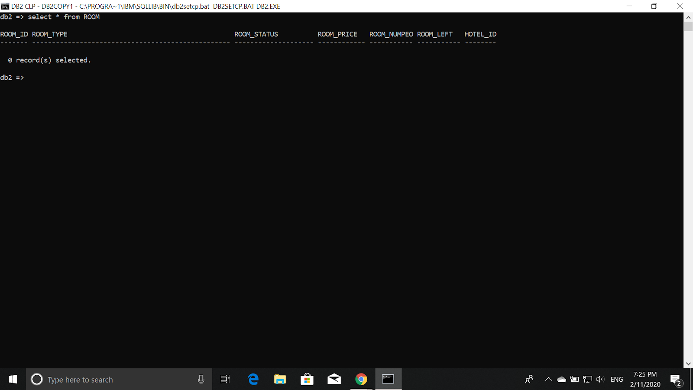

Explanation : The syntaxes above created the ROOM table.

CREATE TABLE GUEST(

GUEST_ID VARCHAR(5) PRIMARY KEY NOT NULL,

GUEST_NRIC VARCHAR(30) NOT NULL UNIQUE ,

GUEST_NAME VARCHAR(50) ,

GUEST_PHONE VARCHAR(15) ,

GUEST_GENDER CHAR(1) CHECK (GUEST_GENDER IN ('F','M')),

GUEST_EMAIL VARCHAR(50) NOT NULL UNIQUE,

GUEST_PWORD VARCHAR(50)

)

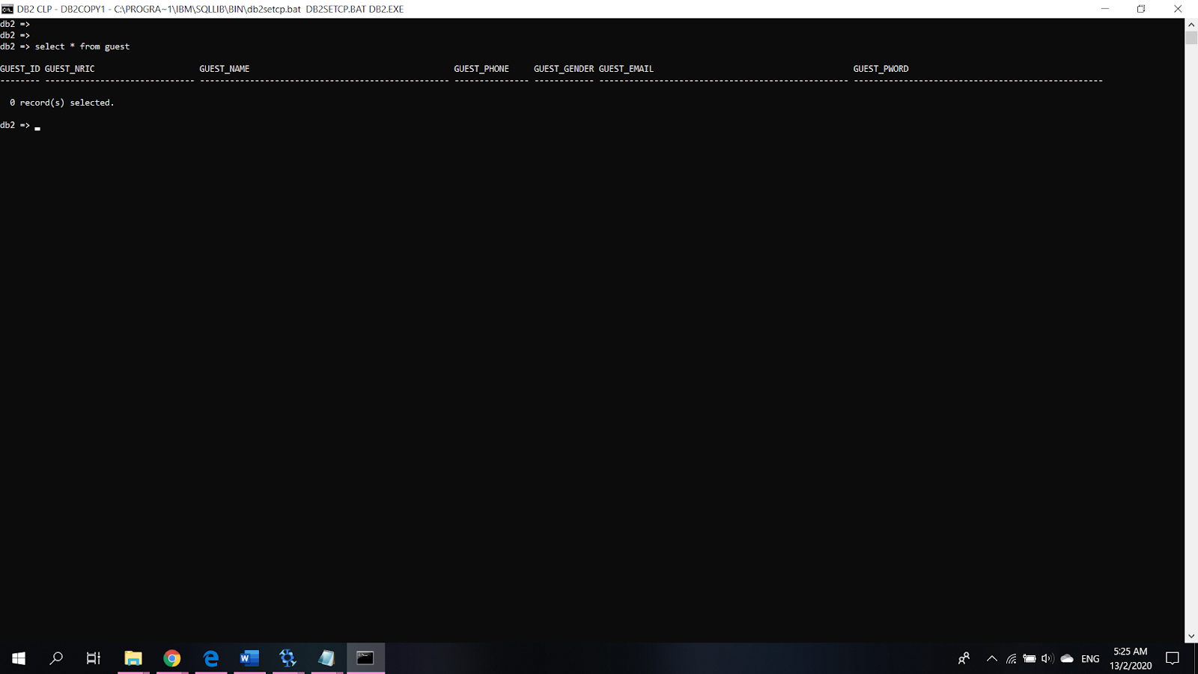

Explanation : The syntaxes above created the GUEST table and GUEST_GENDER can be either F or M only.

CREATE TABLE PROMOTION(

PROMO_ID VARCHAR(5) PRIMARY KEY NOT NULL,

PROMO_TYPE VARCHAR(30) ,

PROMO_STARTDATE DATE ,

PROMO_ENDDATE DATE ,

PROMO_VALUE DECIMAL(3,2) ,

PROMO_AVAIL INTEGER

)

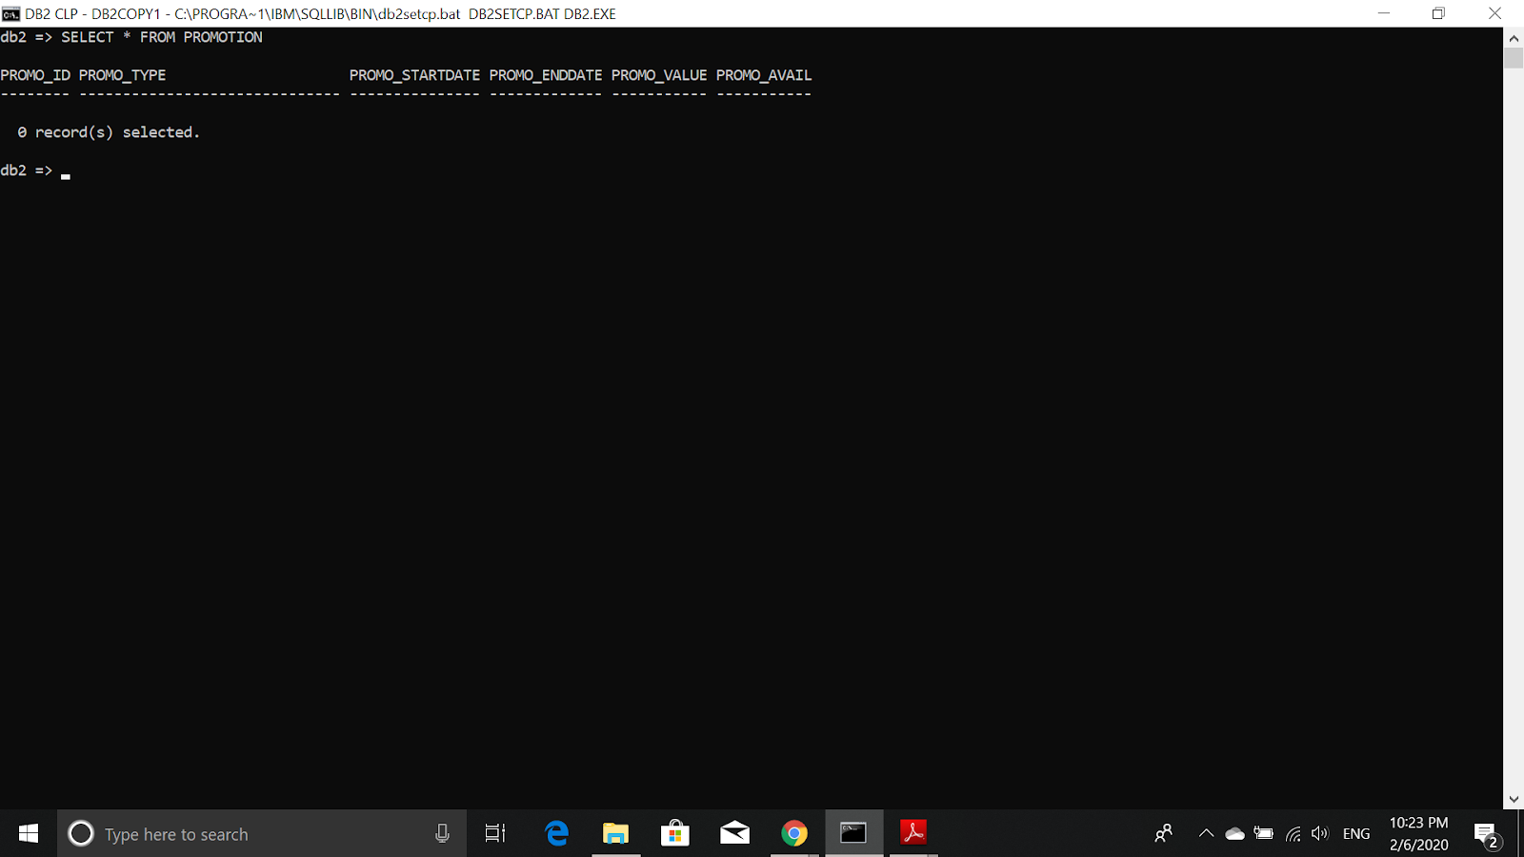

Explanation : The syntaxes above created the PROMOTION table.

CREATE TABLE BOOKINGSUMMARY(

BKGSUM_ID INTEGER PRIMARY KEY NOT NULL GENERATED ALWAYS AS IDENTITY(START WITH 100 INCREMENT BY 1),

TOTAL_PRICE DECIMAL(10,2) ,

PAY_TYPE VARCHAR(20) ,

PAY_STATUS VARCHAR(20) ,

PROMO_ID VARCHAR(5),

FOREIGN KEY(PROMO_ID) REFERENCES PROMOTION

)

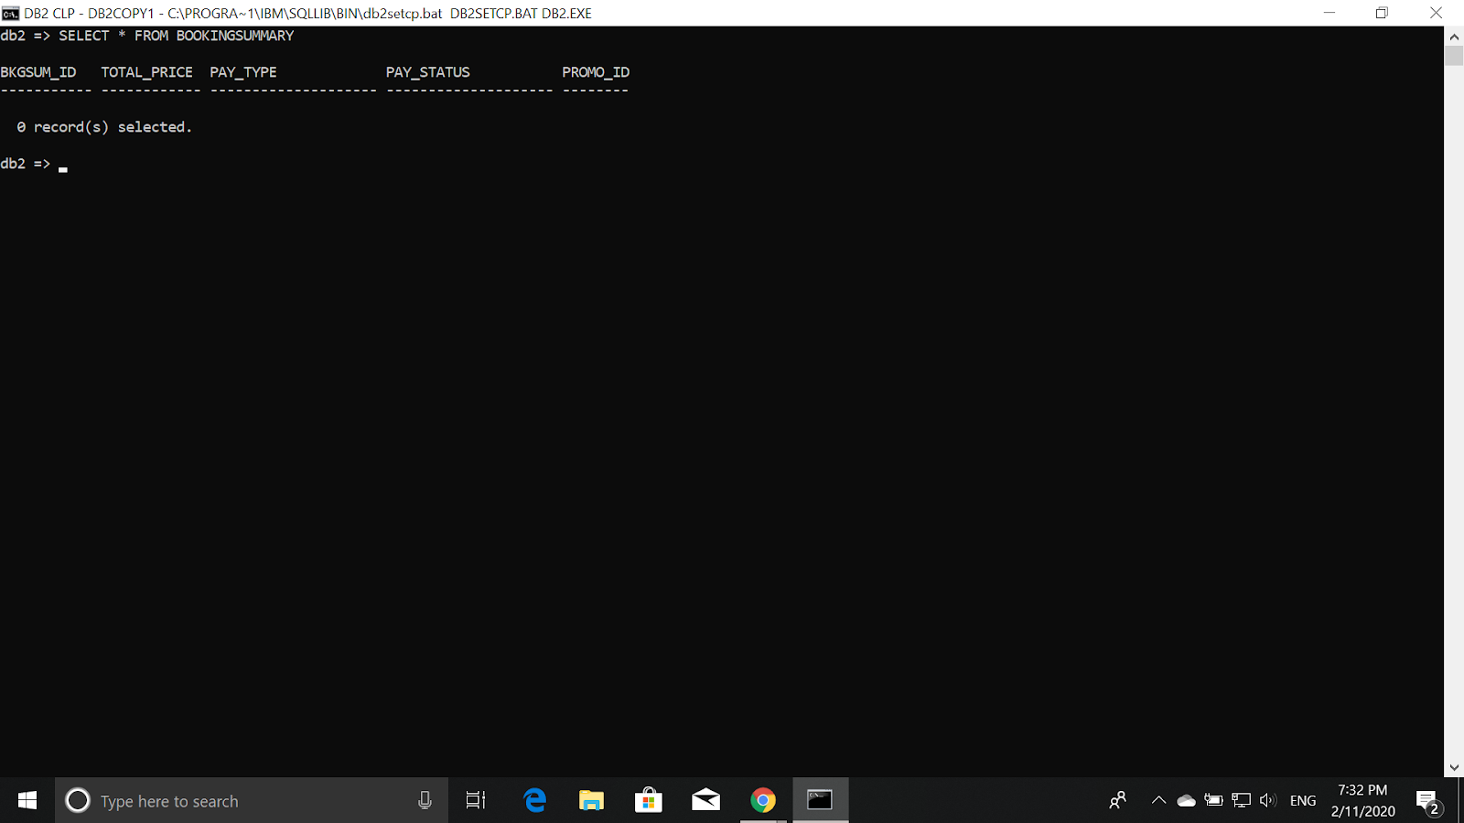

Explanation : The syntaxes above created the BOOKINGSUMMARY table and the BKSUM_ID will automatically increment by 1 for every new row inserted to BOOKINGSUMMARY.

CREATE TABLE BOOKINGDETAILS(

BKGDET_ID VARCHAR(5) PRIMARY KEY NOT NULL,

CHECKIN_D DATE NOT NULL,

CHECKOUT_D DATE NOT NULL,

TOTAL_ROOM_PRICE DECIMAL(10,2),

GUEST_ID VARCHAR(5),

ROOM_ID VARCHAR(5),

BKGSUM_ID INTEGER,

FOREIGN KEY(GUEST_ID) REFERENCES GUEST,

FOREIGN KEY(ROOM_ID) REFERENCES ROOM,

FOREIGN KEY (BKGSUM_ID) REFERENCES BOOKINGSUMMARY

)

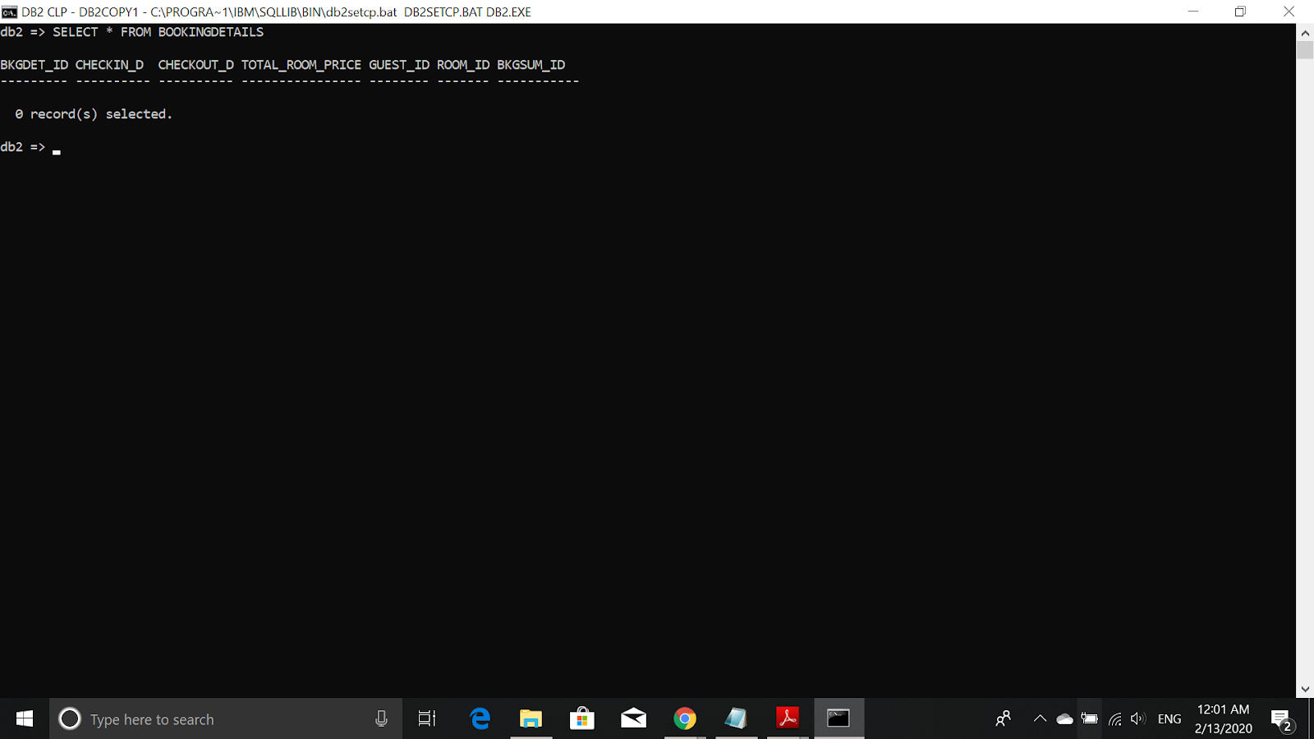

Explanation : The syntaxes above created the BOOKINGDETAILS table.

# 

# **DATA INSERTION**

**HOTEL**

INSERT INTO HOTEL(HOTEL_ID, HOTEL_NAME, HOTEL_PHONE, HOTEL_RATING, HOTEL_STREET, HOTEL_POS, HOTEL_CITY, HOTEL_STATE ) VALUES ('H0001', 'Citadines Dpulze Cyberjaya','60386899999' ,8.5 , 'Cyber 12', '63000', 'Cyberjaya', 'Selangor')

INSERT INTO HOTEL VALUES('H0002', 'Grand Cyberjaya Hotel ','60122365118', 7.7, 'Grand Hotel ', 'Cyber 12', '63000', 'Cyberjaya', 'Selangor')

INSERT INTO HOTEL VALUES('H0003', 'Grand Kapar Hotel', '60333623020', 6, 'Grand Hotel', '30 Jalan Klang Sentral', '42200', 'Klang', 'Selangor')

INSERT INTO HOTEL VALUES('H0004', 'OYO Hotel Shah Alam ','60444555661', 8.2 ,'OYO Hotel ', '19 Jalan Keluli', '40000', 'Klang', 'Selangor')

INSERT INTO HOTEL VALUES('H0005', 'Melia Kuala Lumpur','60327852828', 7.8, 'Melia Hotel', '16 Jalan Imbi', '55100', 'Kuala Lumpur', 'Kuala Lumpur')

INSERT INTO HOTEL(HOTEL_ID, HOTEL_NAME, HOTEL_PHONE, HOTEL_RATING, HOTEL_STREET, HOTEL_POS, HOTEL_CITY, HOTEL_STATE ) VALUES('H0006', 'Le Meridien Kuala Lumpur', '60603226378', 9.3, '2 Jalan Stesen Sentral', '50470', 'Kuala Lumpur', 'Kuala Lumpur')

INSERT INTO HOTEL(HOTEL_ID, HOTEL_NAME, HOTEL_PHONE, HOTEL_RATING, HOTEL_STREET, HOTEL_POS, HOTEL_CITY, HOTEL_STATE ) VALUES('H0007', 'Hotel Casa Del Mar Langkawi', '60601245634', 9.6,'Jalan Pantai Cenang', '07000', 'Pantai Cenang', 'Kedah')

INSERT INTO HOTEL VALUES('H0008', 'OYO Hotel Langkawi', '60601234998', 9.5, 'OYO Hotel ', 'Telaga Harbour Park', '07000', 'Pantai Kok', 'Kedah')

INSERT INTO HOTEL VALUES('H0009', 'OYO Hotel 89312', '60601289542', 9.2, 'OYO Hotel', '10 Jalan Ceylon', '80200', 'Johor Bahru', 'Johor')

INSERT INTO HOTEL VALUES('H0010', 'Melia Johor', '60601333342', 8.3, 'Melia Hotel', '260 Jalan Dato Sulaiman', '80250', 'Johor Bahru', 'Johor')

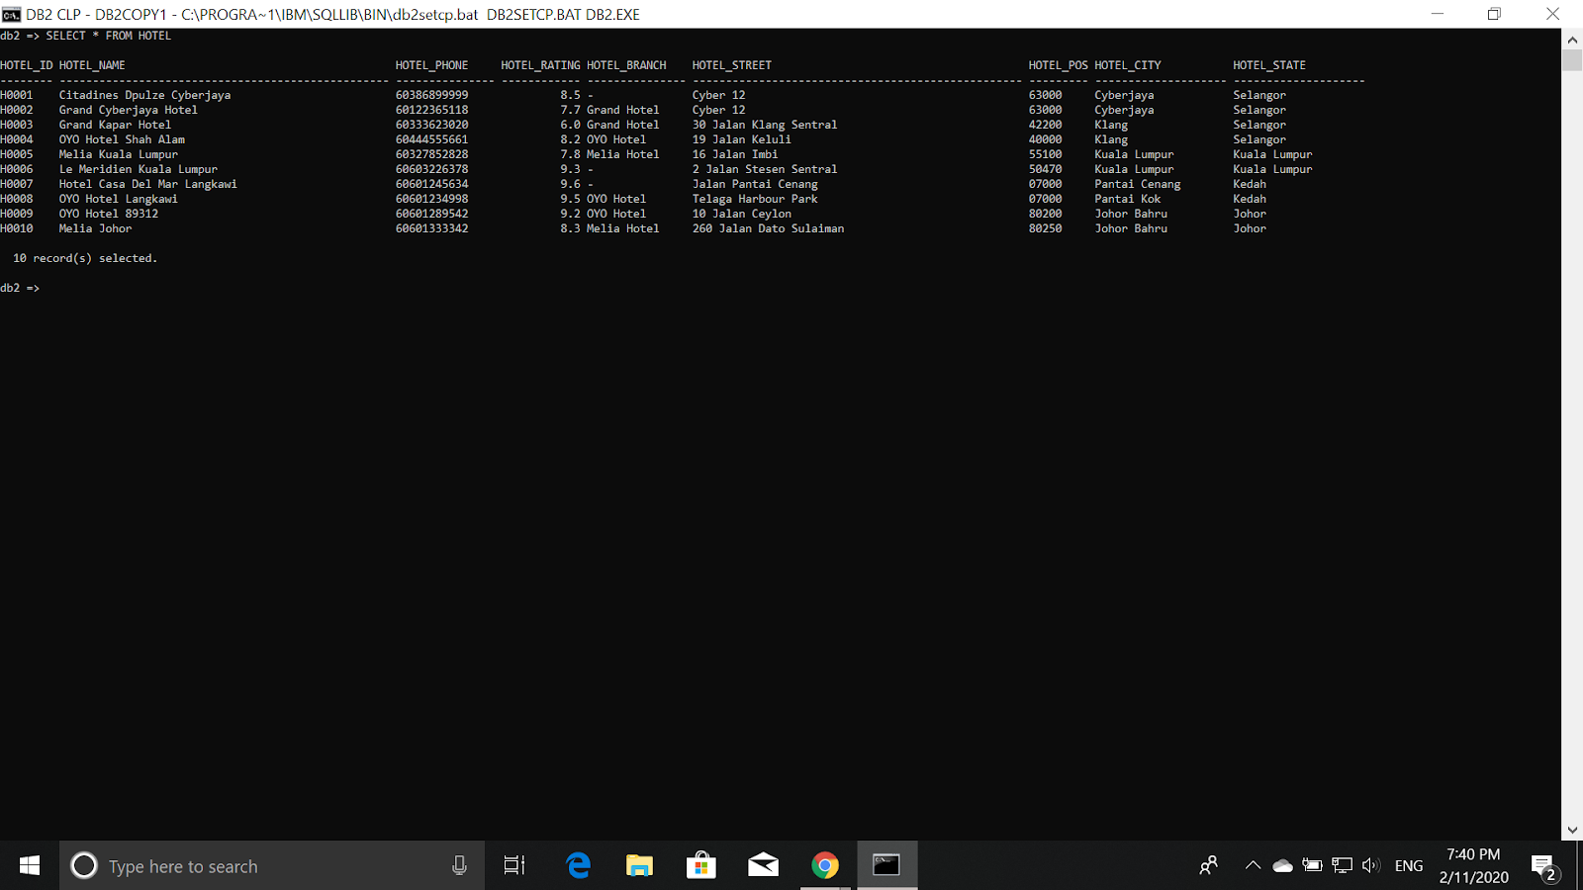

**ROOM**

INSERT INTO ROOM VALUES('R0001','One-Bedroom Suite', DEFAULT, 299.00, 2 , 20, 'H0001')

INSERT INTO ROOM VALUES('R0002', 'Two-Bedroom Suite', DEFAULT, 399.00, 4, 25, 'H0001')

INSERT INTO ROOM VALUES('R0003', 'Deluxe Double Room', 'Not Available', 120.00, 2, 0, 'H0001')

INSERT INTO ROOM VALUES('R0004', 'Standard Single Room', DEFAULT, 49.00, 1, 14, 'H0002')

INSERT INTO ROOM VALUES('R0005', 'Deluxe Double Room', DEFAULT,69.00, 2, 30, 'H0002')

INSERT INTO ROOM VALUES('R0006', 'Deluxe Single Room', 'Not Available', 69.00, 1, 0, 'H0002')

INSERT INTO ROOM VALUES('R0007', 'Deluxe Double Room', DEFAULT, 69.00, 2, 23, 'H0003')

INSERT INTO ROOM VALUES('R0008', 'Standard Single Room', DEFAULT,50.00, 1, 15, 'H0003')

INSERT INTO ROOM VALUES('R0009 ', 'Deluxe Single Room', DEFAULT, 69.00, 1, 10, 'H0003')

INSERT INTO ROOM VALUES('R0010', 'Standard Family Room', DEFAULT, 250.00, 6 ,23, 'H0004')

INSERT INTO ROOM VALUES('R0011', 'Standard Double Room', DEFAULT, 98.00, 2 ,42, 'H0004')

INSERT INTO ROOM VALUES('R0012' ,'Deluxe Double Room', DEFAULT, 128.00, 2, 37, 'H0004')

INSERT INTO ROOM VALUES('R0013', 'Deluxe Single Room', DEFAULT, 180.00, 1 , 21, 'H0005')

INSERT INTO ROOM VALUES('R0014', 'Deluxe Double Room', DEFAULT, 180.00, 2, 13, 'H0005')

INSERT INTO ROOM VALUES('R0015', 'Standard Double Room', 'Not Available', 140.00, 2 , 0, 'H0005')

INSERT INTO ROOM VALUES('R0016', 'Deluxe Family Room', DEFAULT, 650.00, 6, 19, 'H0006')

INSERT INTO ROOM VALUES('R0017', 'Standard Family Room', 'Not Available', 550.00, 6, 0, 'H0006')

INSERT INTO ROOM VALUES('R0018', 'Deluxe Family Room', DEFAULT, 830.00, 4, 20, 'H0006')

INSERT INTO ROOM VALUES('R0019', 'Standard Family Room', DEFAULT, 450.00, 6, 47, 'H0007')

INSERT INTO ROOM VALUES('R0020', 'Deluxe Family Room', DEFAULT,540.00, 6, 34, 'H0007')

INSERT INTO ROOM VALUES('R0021', 'Two-Bedroom Suite', DEFAULT, 710.00, 4, 7, 'H0007')

INSERT INTO ROOM VALUES('R0022', 'Deluxe Double Room', DEFAULT, 380.00, 2, 18, 'H0008')

INSERT INTO ROOM VALUES('R0023', 'Deluxe Single Room', DEFAULT, 380.00, 1, 16, 'H0008')

INSERT INTO ROOM VALUES('R0024', 'Standard Family Room', 'Not Available', 520.00, 6, 0, 'H0008')

INSERT INTO ROOM VALUES('R0025', 'Standard Single Room', DEFAULT, 120.00, 1, 11, 'H0009')

INSERT INTO ROOM VALUES('R0026', 'Deluxe Double Room', 'Not Available',140.00, 2, 0, 'H0009')

INSERT INTO ROOM VALUES('R0027', 'Two-Bedroom Suite', DEFAULT, 450.00, 4, 5, 'H0010')

INSERT INTO ROOM VALUES('R0028', 'One-Bedroom Suite', 'Not Available',350.00, 2, 0, 'H0010')

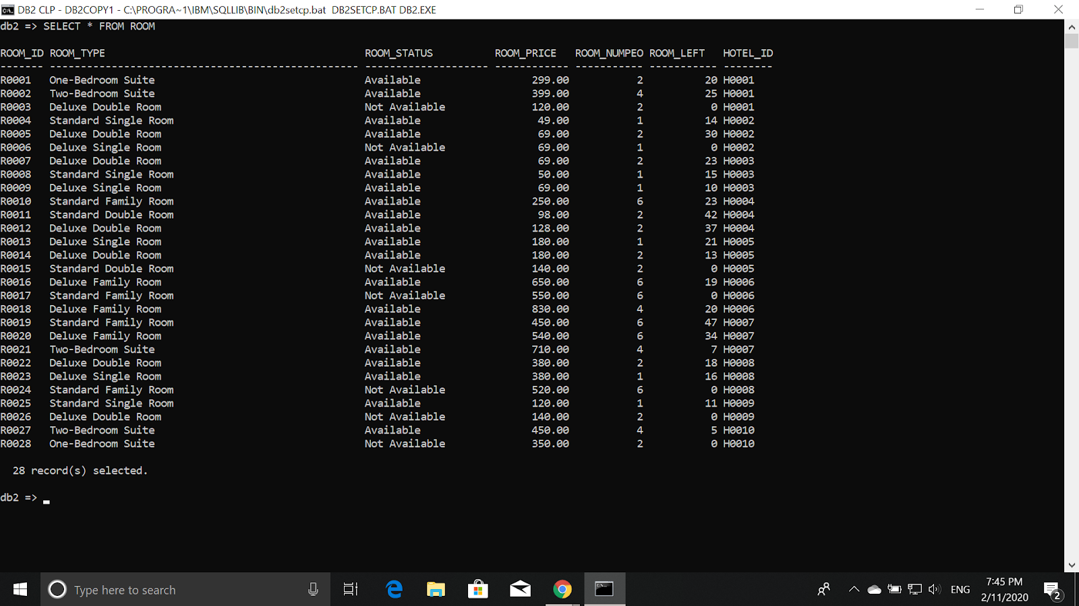

**GUEST**

INSERT INTO GUEST VALUES('G0001', '000311-01-1981', 'SOH XUAN WEI', '01234574636', 'M', 'xuanwei122@gmail.com', 'xuanwei520')

INSERT INTO GUEST VALUES('G0002', '000412-02-1343', 'LIM KAI XUAN', '01345735783', 'M', '[kaixuan8899@gmail.com](mailto:kaixuan8899@gmail.com)','kaikai1122')

INSERT INTO GUEST VALUES('G0003', '000520-07-1499', 'NG JUN WEI', '01758835345', 'M', 'weiweihaha12@gmail.com', 'weiwei0909')

INSERT INTO GUEST VALUES('G0004', '000510-01-1388', 'TEO YEE XUAN', '01223474634', 'F', 'yeexuan0920@gmail.com', 'yeexuan123')

INSERT INTO GUEST VALUES('G0005', '000520-01-1399', 'SOH YU ZHEN', '01234523487', 'M', 'sohsoh1212@gmail.com', 'sohsoh45678')

INSERT INTO GUEST VALUES('G0006', '000430-01-1677', 'SOH JIN ZHE', '01256435332', 'M', 'sohzhezhe@gmail.com', 'zhezhe1677')

INSERT INTO GUEST VALUES('G0007', '000720-03-1982', 'LIM ZHI QING', '01123646842', 'F', 'qingqing03@gmail.com', 'qingqing0720')

INSERT INTO GUEST VALUES('G0008', '000120-09-2031', 'MUHAMMAD FARIS', '01354674561', 'M', 'faris2031@gmail.com', 'faris2031')

INSERT INTO GUEST VALUES('G0009', '001120-01-2099', 'DANNY' ,'01256357463', 'M', 'tomlovejerry@gmail.com', 'iamtom0425@siti')

INSERT INTO GUEST VALUES('G0010', '001230-05-2031', 'MUHAMMAD JOHN', '01923634735', 'M', 'HIIAMJOGN@gmail.com', 'johnwhereareyou')

INSERT INTO GUEST VALUES('G0011', '001130-01-1022', 'MINDY', '017892376612', 'F', 'mindy1130@gmail.com', 'mindy1022@1130')

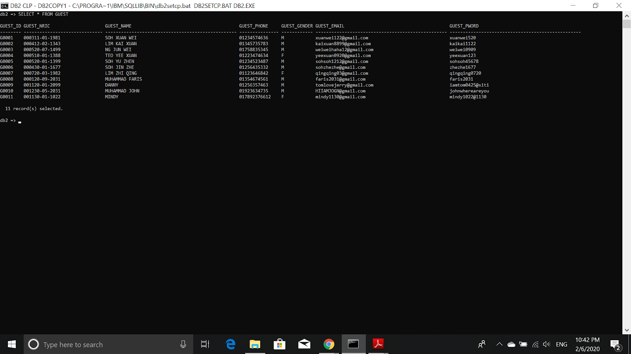

**PROMOTION**

INSERT INTO PROMOTION VALUES('D0001', 'HARI MERDEKA DISCOUNT', '2020-08-31','2020-09-01', 0.7, 10)

INSERT INTO PROMOTION VALUES('D0002', 'CHINESE NEW YEAR DISCOUNT', '2020-01-25', '2020-01-26', 0.7,10)

INSERT INTO PROMOTION VALUES('D0003', 'HARI RAYA DISCOUNT', '2020-05-23','2020-05-24', 0.65, 9)

INSERT INTO PROMOTION VALUES('D0004', 'NEW YEAR DISCOUNT', '2019-12-31','2020-01-01', 0.75,10)

INSERT INTO PROMOTION VALUES('D0005', 'VALENTINE DAY DISCOUNT', '2020-02-14', '2020-02-15', 0.75,10)

INSERT INTO PROMOTION VALUES('D0006', 'CHRISTMAS DISCOUNT', '2020-12-24', '2020-12-25', 0.8, 10)

INSERT INTO PROMOTION VALUES('D0007', 'MALAYSIA DAY DISCOUNT', '2020-09-16', '2020-09-17', 0.9,10)

INSERT INTO PROMOTION VALUES('D0008', 'DOUBLE ELEVENTH DAY', '2020-11-11', '2020-11-12',0.9,10)

INSERT INTO PROMOTION VALUES('D0009', 'MID-AUTUMN FESTIVAL DISCOUNT', '2020-10-01', '2020-10-02', 0.9,10)

INSERT INTO PROMOTION VALUES('D0010', 'DEEPAVALI DISCOUNT', '2020-10-27', '2020-10-28',0.9, 10)

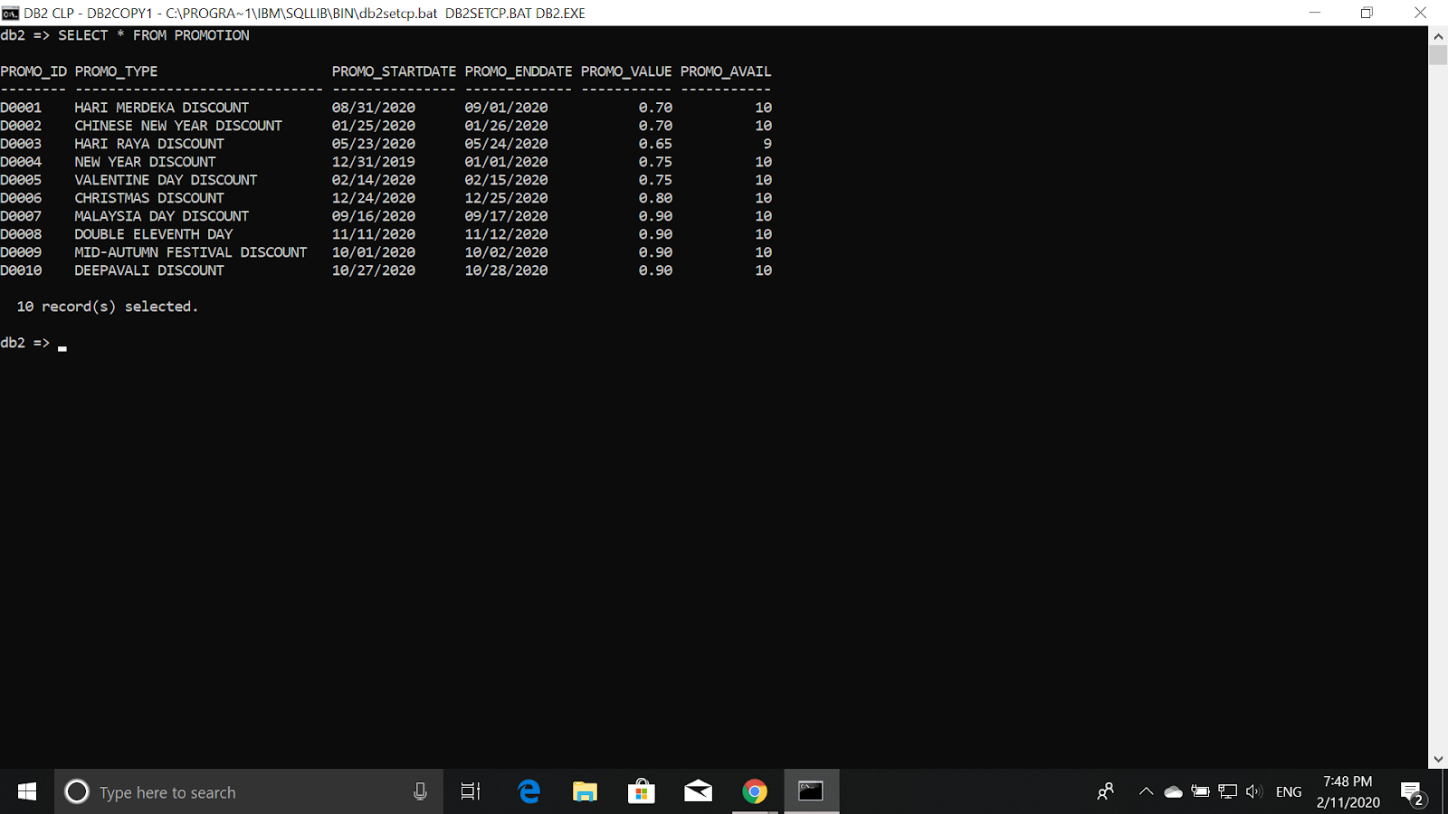

**BOOKINGSUMMARY**

INSERT INTO BOOKINGSUMMARY(BKGSUM_ID, TOTAL_PRICE, PAY_TYPE, PAY_STATUS)VALUES(default, 828.00, 'CASH', 'PAID')

INSERT INTO BOOKINGSUMMARY(BKGSUM_ID, TOTAL_PRICE, PAY_TYPE, PAY_STATUS) VALUES(default, 452.00, 'CASH', 'PENDING')

INSERT INTO BOOKINGSUMMARY(BKGSUM_ID, TOTAL_PRICE, PAY_TYPE, PAY_STATUS) VALUES(default, 2370.00, 'ONLINE TRANSFER', 'PAID')

INSERT INTO BOOKINGSUMMARY(BKGSUM_ID, TOTAL_PRICE, PAY_TYPE, PAY_STATUS) VALUES(default, 1100.00, 'ONLINE TRANSFER', 'PAID')

INSERT INTO BOOKINGSUMMARY(BKGSUM_ID, TOTAL_PRICE, PAY_TYPE, PAY_STATUS) VALUES(default, 1660.00, 'CASH', 'PENDING')

INSERT INTO BOOKINGSUMMARY(BKGSUM_ID, TOTAL_PRICE, PAY_TYPE, PAY_STATUS) VALUES(default, 1620.00, 'ONLINE TRANSFER', 'PAID')

INSERT INTO BOOKINGSUMMARY(BKGSUM_ID, TOTAL_PRICE, PAY_TYPE, PAY_STATUS) VALUES(default, 240.00, 'CASH', 'PENDING')

INSERT INTO BOOKINGSUMMARY(BKGSUM_ID, TOTAL_PRICE, PAY_TYPE, PAY_STATUS) VALUES(default, 49.00, 'CREDIT CARD', 'PAID')

INSERT INTO BOOKINGSUMMARY(BKGSUM_ID, TOTAL_PRICE, PAY_TYPE, PAY_STATUS) VALUES(default, 900.00, 'ONLINE TRANSFER','PAID')

INSERT INTO BOOKINGSUMMARY(BKGSUM_ID, TOTAL_PRICE, PAY_TYPE, PAY_STATUS) VALUES(default, 2700.00, 'ONLINE TRANSFER', 'PAID')

INSERT INTO BOOKINGSUMMARY(BKGSUM_ID, TOTAL_PRICE, PAY_TYPE, PAY_STATUS) VALUES(default, 900.00, 'CASH', 'PENDING')

INSERT INTO BOOKINGSUMMARY VALUES(default, 1478.10, 'CREDIT CARD', 'PAID', 'D0003')

INSERT INTO BOOKINGSUMMARY(BKGSUM_ID, TOTAL_PRICE, PAY_TYPE, PAY_STATUS) VALUES(default, 280.00, 'CASH', 'PENDING')

INSERT INTO BOOKINGSUMMARY(BKGSUM_ID, TOTAL_PRICE, PAY_TYPE, PAY_STATUS) VALUES(default, 350.00,'CASH', 'PENDING')

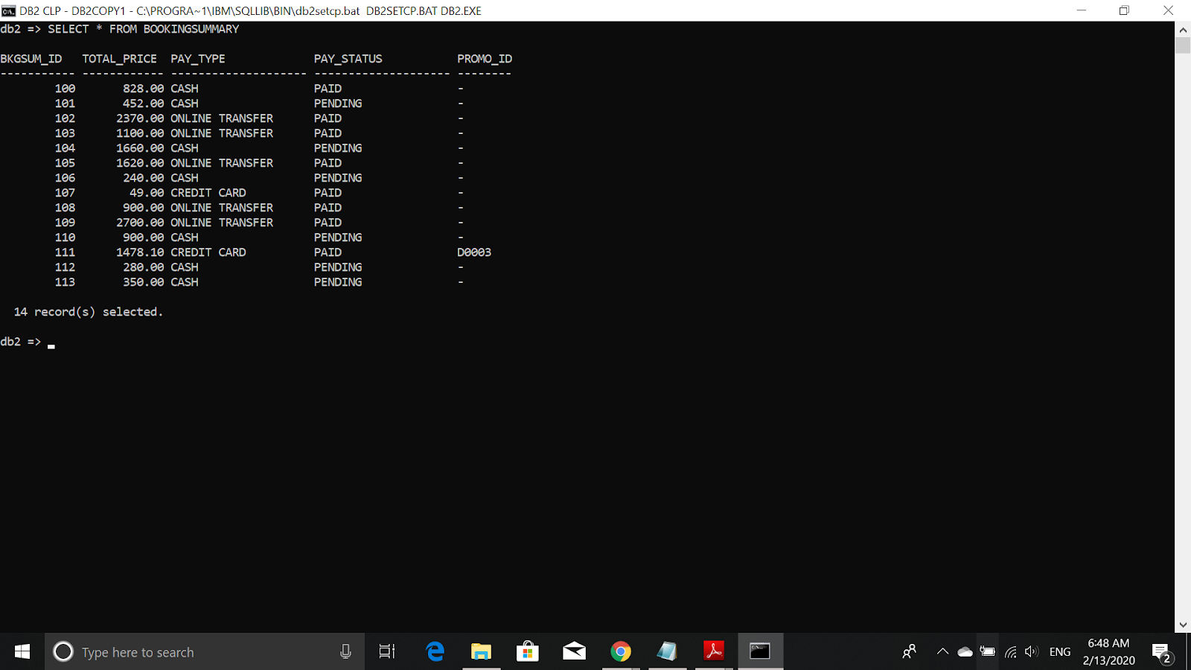

**BOOKINGDETAILS**

INSERT INTO BOOKINGDETAILS VALUES('B0001', '2020-01-27', '2020-02-02', 414.00, 'G0001', 'R0006',100)

INSERT INTO BOOKINGDETAILS VALUES('B0002', '2020-01-27', '2020-02-02', 414.00, 'G0001', 'R0007',100)

INSERT INTO BOOKINGDETAILS VALUES('B0003', '2020-02-27', '2020-02-29', 196.00, 'G0002', 'R0011',101)

INSERT INTO BOOKINGDETAILS VALUES('B0004', '2020-02-27', '2020-02-29', 256.00, 'G0002', 'R0012',101)

INSERT INTO BOOKINGDETAILS VALUES('B0005', '2020-02-28', '2020-03-02', 420.00, 'G0003', 'R0015',102)

INSERT INTO BOOKINGDETAILS VALUES('B0006', '2020-02-28', '2020-03-02', 1950.00, 'G0003', 'R0016',102)

INSERT INTO BOOKINGDETAILS VALUES('B0007', '2020-03-24', '2020-03-26', 1100.00, 'G0004', 'R0017',103)

INSERT INTO BOOKINGDETAILS VALUES('B0008', '2020-03-28', '2020-03-30', 1660.00, 'G0004', 'R0018',104)

INSERT INTO BOOKINGDETAILS VALUES('B0009', '2020-04-05', '2020-04-08', 1620.00, 'G0005', 'R0020',105)

INSERT INTO BOOKINGDETAILS VALUES('B0010', '2020-04-11', '2020-04-13', 240.00, 'G0006', 'R0003',106)

INSERT INTO BOOKINGDETAILS VALUES('B0011', '2020-04-27', '2020-04-28', 49.00, 'G0007', 'R0004',107)

INSERT INTO BOOKINGDETAILS VALUES('B0012', '2020-05-01', '2020-05-03', 900.00, 'G0008', 'R0027',108)

INSERT INTO BOOKINGDETAILS VALUES('B0013', '2020-05-11', '2020-05-14', 1140.00, 'G0009', 'R0023',109)

INSERT INTO BOOKINGDETAILS VALUES('B0014', '2020-05-11', '2020-05-14', 1560.00, 'G0009', 'R0024',109)

INSERT INTO BOOKINGDETAILS VALUES('B0015', '2020-05-20', '2020-05-22', 900.00, 'G0009', 'R0027',110)

INSERT INTO BOOKINGDETAILS VALUES('B0016', '2020-05-22', '2020-05-25', 360.00, 'G0010', 'R0025',111)

INSERT INTO BOOKINGDETAILS VALUES('B0017', '2020-05-22', '2020-05-25', 1620.00, 'G0010', 'R0020',111)

INSERT INTO BOOKINGDETAILS VALUES('B0018', '2020-05-22', '2020-05-25', 294.00, 'G0010', 'R0011',111)

INSERT INTO BOOKINGDETAILS VALUES('B0019', '2020-06-02', '2020-06-04', 280.00, 'G0011', 'R0026',112)

INSERT INTO BOOKINGDETAILS VALUES('B0020', '2020-06-12', '2020-06-13', 350.00, 'G0011', 'R0028',113)

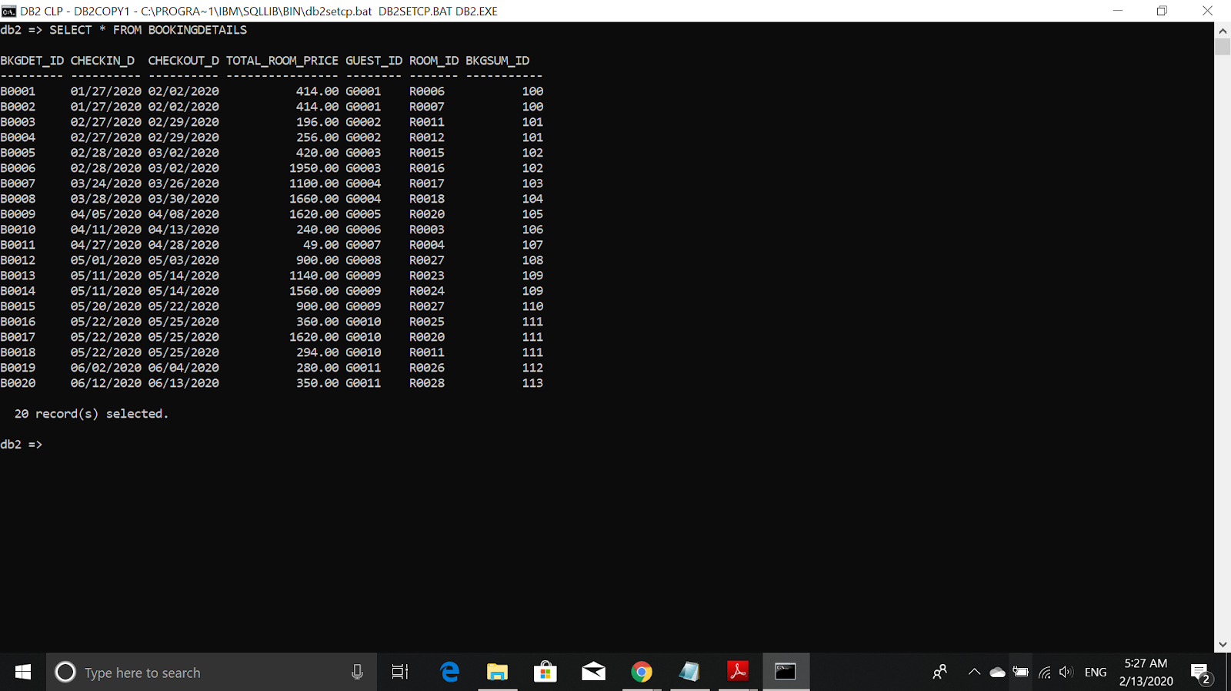

# **DATA MANIPULATION LANGUAGE (DML)**

## **AGGREGATE FUNCTION**

The total room type provided in the system

SELECT ROOM_TYPE, COUNT(ROOM_TYPE) AS TOTAL

FROM ROOM

GROUP BY ROOM_TYPE

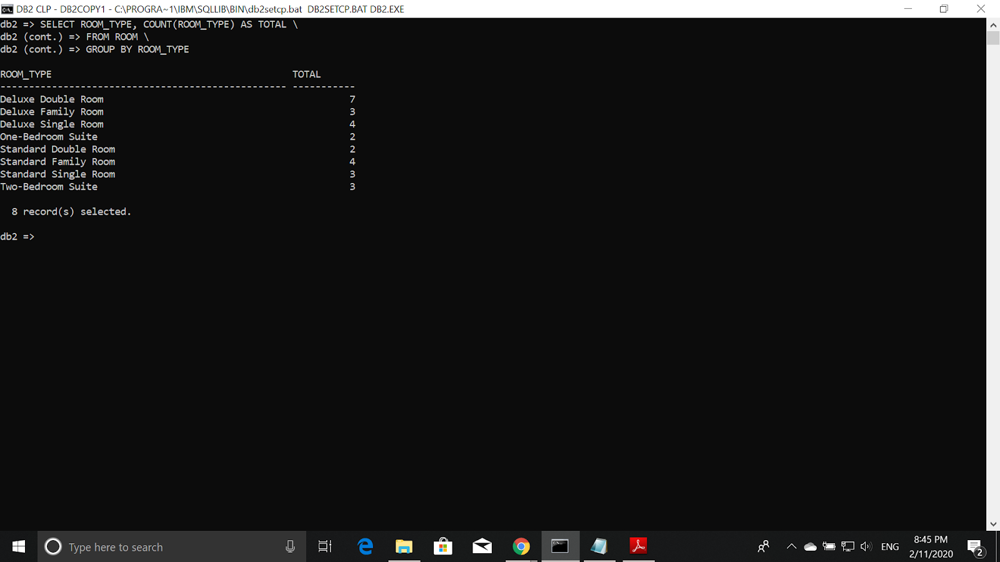

The total Deluxe Double Room left for the hotels in Selangor

SELECT SUM(ROOM_LEFT) AS TOTAL_ROOM_LEFT

FROM ROOM, HOTEL

WHERE HOTEL.HOTEL_ID = ROOM.HOTEL_ID AND

ROOM_TYPE = 'Deluxe Double Room' AND

HOTEL_STATE = 'Selangor'

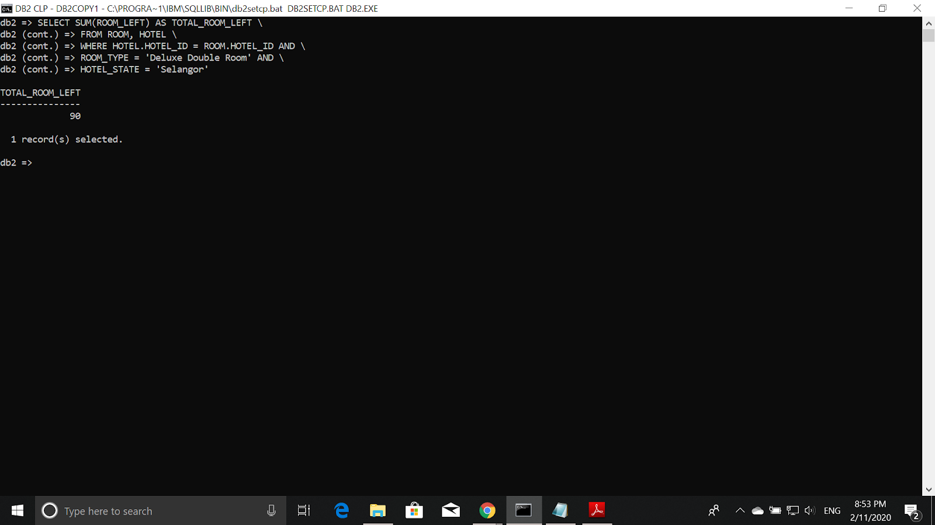

The Average Price of each hotel

SELECT HOTEL_NAME, DECIMAL(AVG(ROOM_PRICE),6,2) AS AVERAGE_PRICE

FROM HOTEL, ROOM

WHERE HOTEL.HOTEL_ID = ROOM.HOTEL_ID

GROUP BY HOTEL_NAME

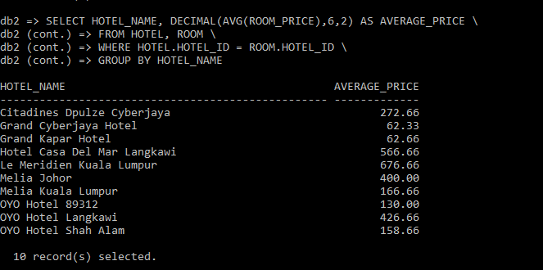

## **QUERY WITH A GROUP BY AND HAVING CLAUSES**

The guest name with the number of bookings made for more than or equal 2

SELECT GUEST_NAME, COUNT(BOOKINGDETAILS.GUEST_ID) AS TOTAL_BOOKINGS

FROM GUEST, BOOKINGDETAILS

WHERE GUEST.GUEST_ID = BOOKINGDETAILS.GUEST_ID

GROUP BY GUEST_NAME, BOOKINGDETAILS.GUEST_ID

HAVING COUNT(BOOKINGDETAILS.GUEST_ID) >= 2

ORDER BY COUNT(BOOKINGDETAILS.GUEST_ID) DESC

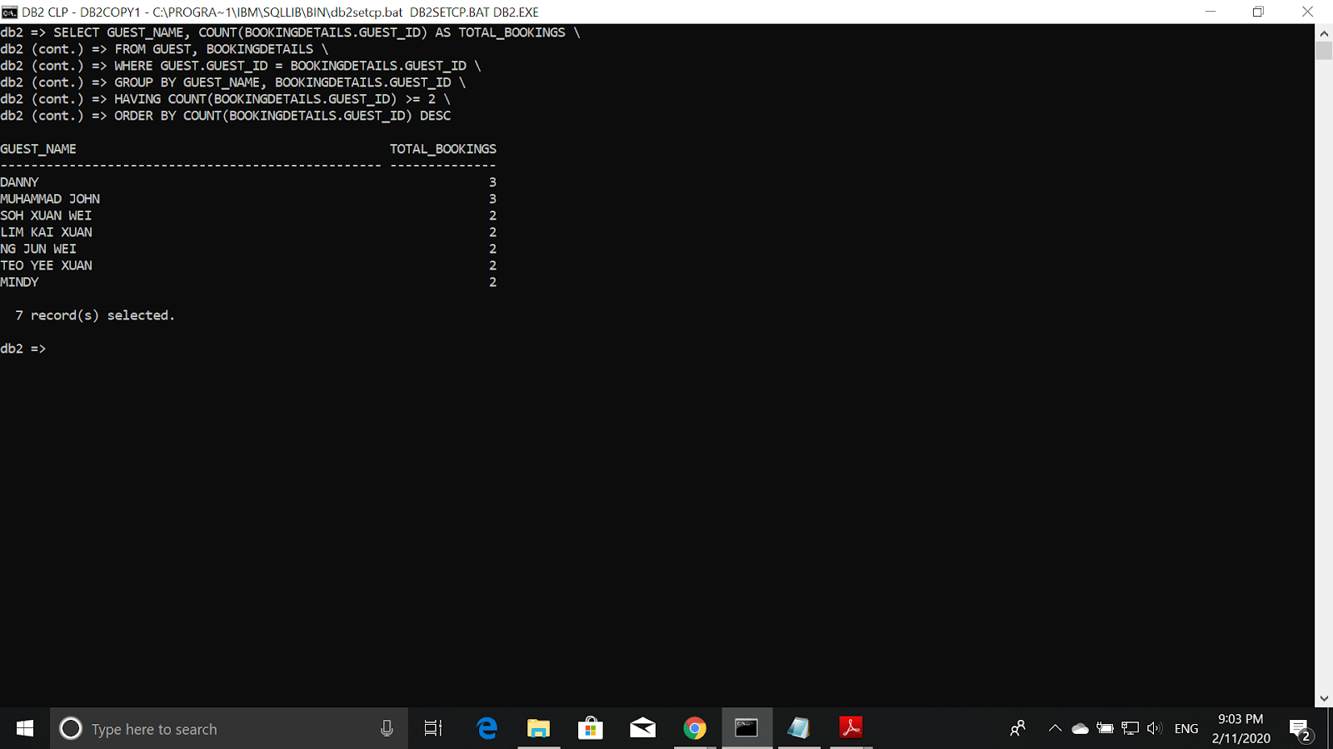

The hotel name with more than 2 types of room available

SELECT HOTEL_NAME, COUNT(ROOM_STATUS) AS TOTAL_ROOM_TYPE_AVAILABLE

FROM HOTEL, ROOM

WHERE HOTEL.HOTEL_ID = ROOM.HOTEL_ID AND ROOM_STATUS = 'Available'

GROUP BY HOTEL_NAME, ROOM_STATUS

HAVING COUNT(ROOM_STATUS) > 2

ORDER BY COUNT(ROOM_STATUS)

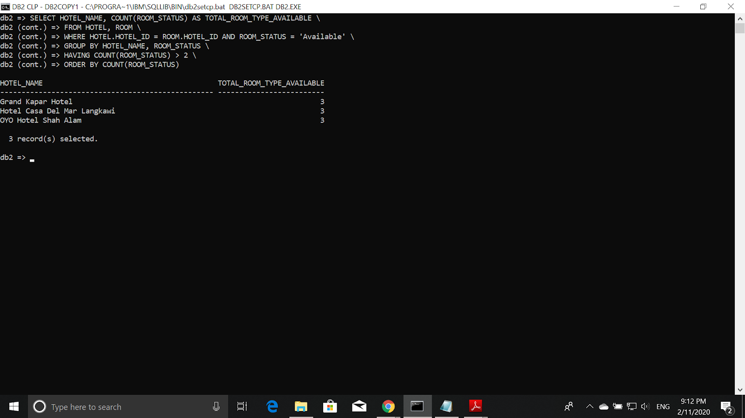

**Hotel name and the number of guests booked with the hotel rating more than 9**

SELECT HOTEL_NAME, COUNT(BOOKINGDETAILS.GUEST_ID) AS TOTAL_GUEST FROM BOOKINGDETAILS, HOTEL, ROOM

WHERE HOTEL.HOTEL_ID = ROOM.HOTEL_ID AND

ROOM.ROOM_ID = BOOKINGDETAILS.ROOM_ID

GROUP BY HOTEL_NAME, HOTEL_RATING

HAVING HOTEL_RATING > 9

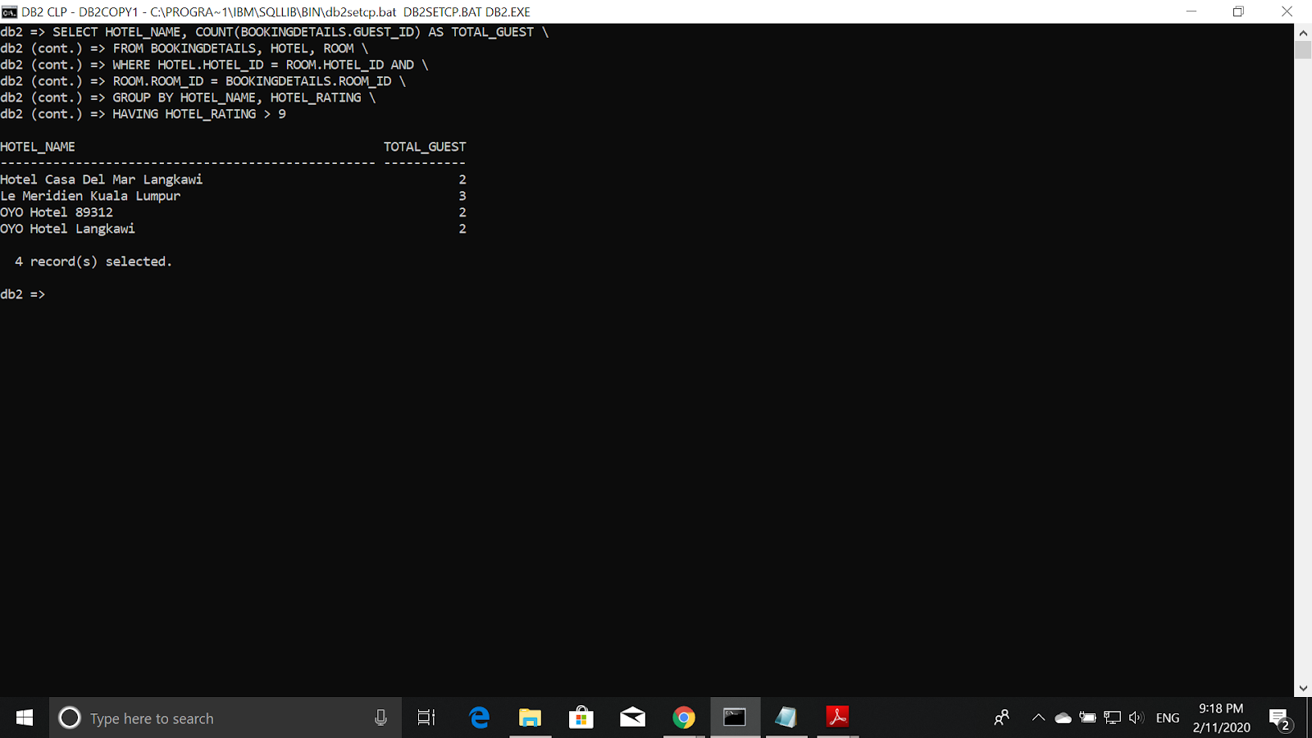

## 

## **TRIGGERS**

**Trigger that will give error message when inserting data to room**

CREATE TRIGGER NEWROOMTRG

NO CASCADE BEFORE INSERT ON ROOM

REFERENCING NEW AS N

FOR EACH ROW MODE DB2SQL

BEGIN

IF INSERTING AND ((N.ROOM_TYPE = 'Deluxe Single Room' OR N.ROOM_TYPE = 'Standard Single Room') AND ROOM_NUMPEO != 1)

THEN

SIGNAL SQLSTATE '75001' SET MESSAGE_TEXT = 'INVALID MAXIMUM PEOPLE IN THAT ROOM';

ELSEIF INSERTING AND ((N.ROOM_TYPE = 'Deluxe Double Room' OR N.ROOM_TYPE = 'Standard Double Room') AND ROOM_NUMPEO != 2)

THEN

SIGNAL SQLSTATE '75001' SET MESSAGE_TEXT = 'INVALID MAXIMUM PEOPLE IN THAT ROOM';

ELSEIF INSERTING AND ((N.ROOM_TYPE = 'Deluxe Family Room' OR N.ROOM_TYPE = 'Standard Family Room') AND ROOM_NUMPEO != 6)

THEN

SIGNAL SQLSTATE '75001' SET MESSAGE_TEXT = 'INVALID MAXIMUM PEOPLE IN THAT ROOM';

ELSEIF INSERTING AND ((N.ROOM_TYPE = 'One-Bedroom Suite') AND ROOM_NUMPEO != 2)

THEN

SIGNAL SQLSTATE '75001' SET MESSAGE_TEXT = 'INVALID MAXIMUM PEOPLE IN THAT ROOM';

ELSEIF INSERTING AND ((N.ROOM_TYPE = 'Two-Bedroom Suite') AND ROOM_NUMPEO != 4)

THEN

SIGNAL SQLSTATE '75001' SET MESSAGE_TEXT = 'INVALID MAXIMUM PEOPLE IN THAT ROOM';

ELSEIF (N.ROOM_TYPE != 'Deluxe Single Room' AND N.ROOM_TYPE != 'Standard Single Room' AND

N.ROOM_TYPE != 'Deluxe Double Room' AND N.ROOM_TYPE != 'Standard Double Room' AND

N.ROOM_TYPE != 'Deluxe Family Room' AND N.ROOM_TYPE != 'Standard Family Room' and

N.ROOM_TYPE != 'One-Bedroom Suite' AND N.ROOM_TYPE != 'Two-Bedroom Suite')

THEN

SIGNAL SQLSTATE '75001' SET MESSAGE_TEXT = 'INVALID ROOM TYPE INSERTED';

END IF;

END

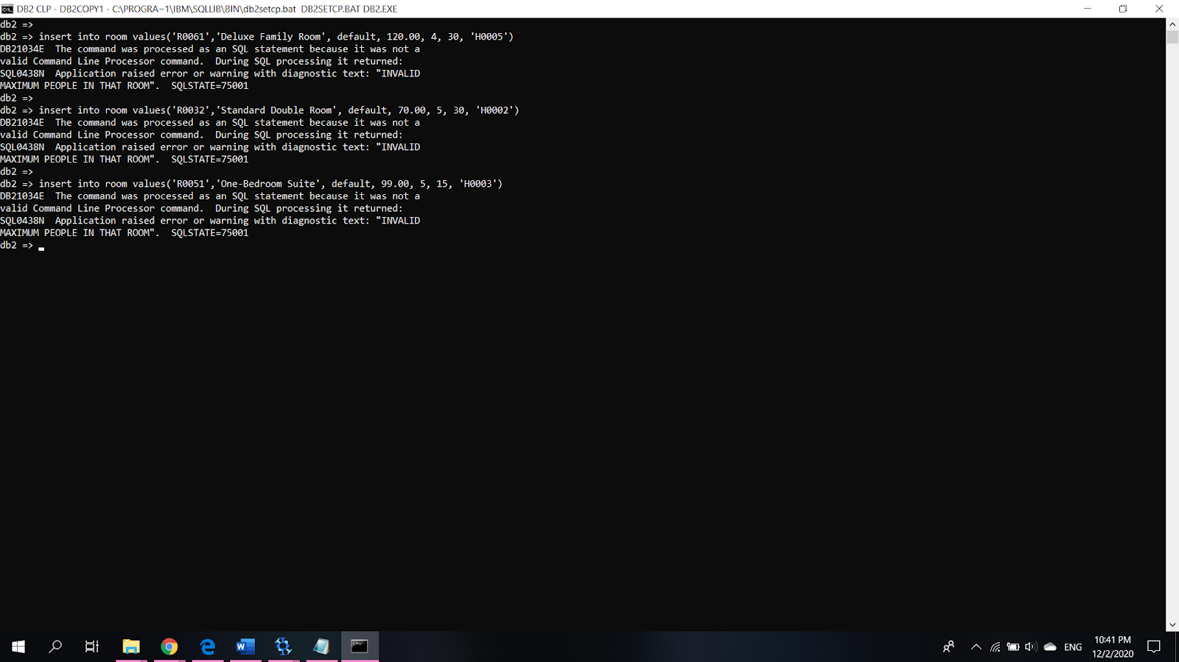

Explanation: This will give an error message when the number of people is invalid for that particular room after inserting data to room

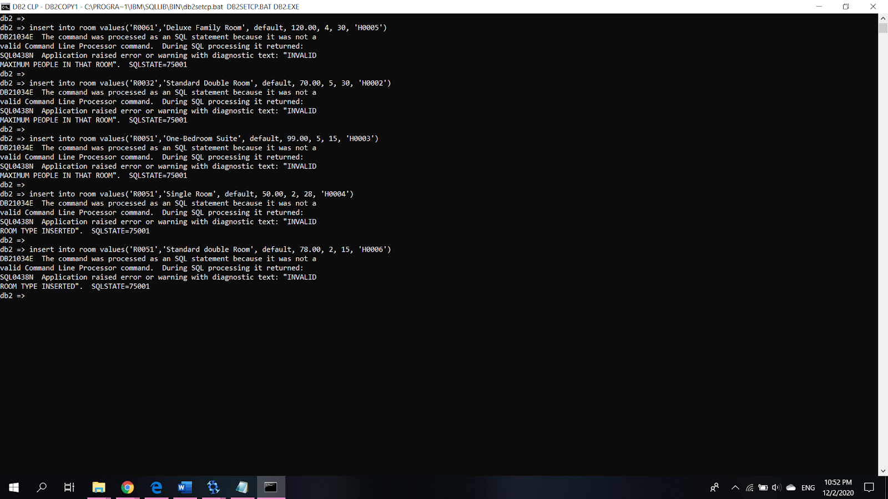

Explanation: This will give an error message when the name of the room type is invalid.

**Trigger to check whether hotel phone is valid**

CREATE TRIGGER CHECK_HOTEL_PHO

BEFORE INSERT OR UPDATE OF HOTEL_PHONE ON HOTEL

REFERENCING NEW AS N

FOR EACH ROW MODE DB2SQL

BEGIN

CASE

WHEN LENGTH(RTRIM(TRANSLATE(HOTEL_PHONE, '*', '1234567890'))) = 0

THEN

ELSE

SIGNAL SQLSTATE '45000'

SET MESSAGE_TEXT = 'THE HOTEL_PHONE NUMBER IS INVALID. ' ;

END CASE;

END

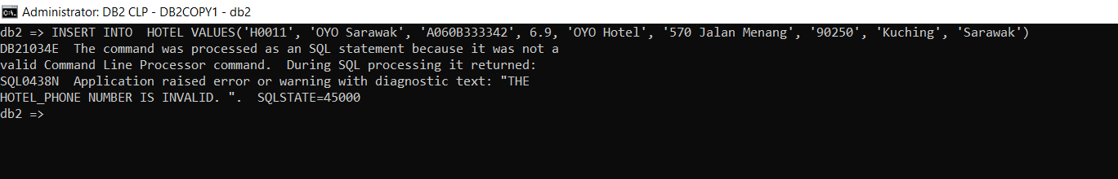

Explanation: This trigger will check whether the hotel_phone contains other than numbers. If hotel_phone contains other than number, it will show an error message “Hotel_phone number is valid.”

**Trigger to check email**

CREATE TRIGGER CHECK_EMAIL

BEFORE INSERT OR UPDATE OF GUEST_EMAIL ON GUEST

REFERENCING NEW AS N

FOR EACH ROW MODE DB2SQL

BEGIN

IF GUEST_EMAIL IS NULL

THEN SIGNAL SQLSTATE '45000'

SET MESSAGE_TEXT = 'THE GUEST’S EMAIL IS INVALID. ' ;

ELSEIF LOCATE(' ',GUEST_EMAIL) <> 0 OR LOCATE('/',GUEST_EMAIL) <> 0 OR LOCATE(' :',GUEST_EMAIL) <> 0 OR LOCATE(' ;',GUEST_EMAIL) <> 0

THEN SIGNAL SQLSTATE '45000'

SET MESSAGE_TEXT = ' THE GUEST’S EMAIL IS INVALID. ' ;

ELSEIF LENGTH(GUEST_EMAIL) -1 <= LOCATE(' .',GUEST_EMAIL)

THEN SIGNAL SQLSTATE '45000'

SET MESSAGE_TEXT = 'THE GUEST’S EMAIL IS INVALID. ' ;

ELSEIF GUEST_EMAIL LIKE '%@%@%' OR GUEST_EMAIL NOT LIKE '%@%.%'

THEN SIGNAL SQLSTATE '45000'

SET MESSAGE_TEXT = 'THE GUEST’S EMAIL IS INVALID. ' ;

END IF;

END

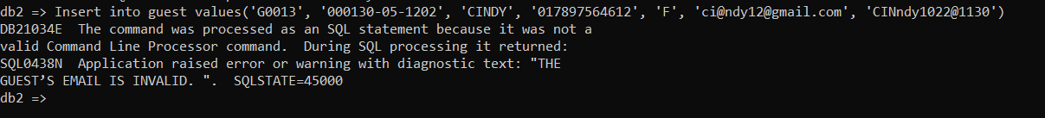

Explanation: This trigger checks whether the email is valid.

**Trigger to count the total price for each booking details**

CREATE TRIGGER trgTotalRoomPrice

AFTER INSERT ON BOOKINGDETAILS

REFERENCING NEW AS N

FOR EACH ROW DB2SQL

UPDATE BOOKINGDETAILS

SET TOTAL_ROOM_PRICE = (SELECT (DAYS(BOOKINGDETAILS.CHECKOUT_D) - DAYS(BOOKINGDETAILS.CHECKIN_D))*ROOM PRICE

FROM ROOM, BOOKINGDETAILS WHERE ROOM.ROOM_ID = BOOKINGDETAILS.ROOM_ID AND BKGDET_ID = N.BKGDET_ID)

WHERE BKGDET_ID = N.BKGDET_ID

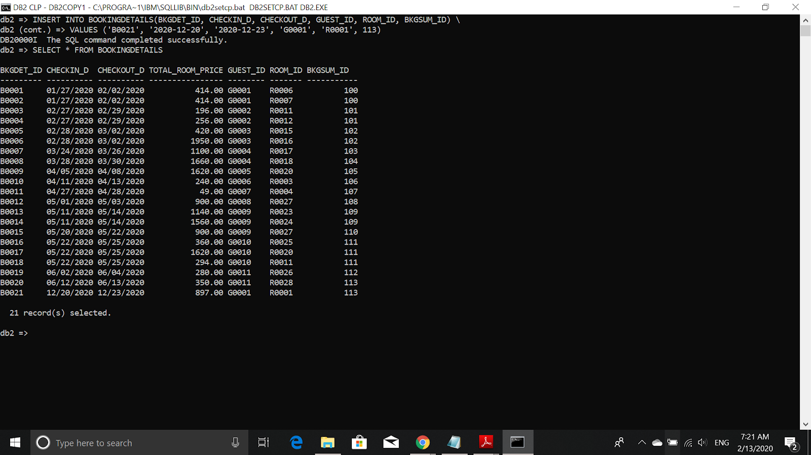

Explanation: The TOTAL_ROOM_PRICE will count the total days and the price for the room for one day automatically after inserting the data.

## 

## **STORED PROCEDURE**

Increase the number of room after customer had check out

CREATE PROCEDURE CHECK_ROOM(IN CHECKIN_D DATE, ROOM_ID VARCHAR(5))

BEGIN

IF (CHECKIN_D >(SELECT CHECKOUT_D FROM BOOKINGDETAILS WHERE ROM_ID = BOOKINGDETAILS.ROOM_ID))

THEN UPDATE ROOM SET(ROOM_LEFT, ROOM_STATUS) = (ROOM_LEFT+1 , 'Available') WHERE ROM_ID = ROOM.ROOM_ID;

ELSEIF CHECKIN_D > (SELECT CHECKIN_D FROM BOOKINGDETAILS WHERE ROM_ID = BOOKINGDETAILS.ROOM_ID) AND CHECKIN_D < (SELECT CHECKOUT_D FROM BOOKINGDETAILS WHERE ROM_ID = BOOKINGDETAILS.ROOM_ID)

THEN SIGNAL SQLSTATE '45000'

SET MESSAGE_TEXT = 'THIS ROOM HAS BEEN BOOKED FOR THE DATE PROVIDED. ' ;

ELSEIF (CHECKIN_D < (SELECT CHECKIN_D FROM BOOKINGDETAILS WHERE ROM_ID = BOOKINGDETAILS.ROOM_ID))

THEN SIGNAL SQLSTATE '45000'

SET MESSAGE_TEXT = 'CANNOT CHOOSE DATE THAT ALREADY PASS. ' ;

END IF;

END

To Execute this procedure:

**CALL CHECK_ROOM(‘05-01-2020’, ‘R0003’)**

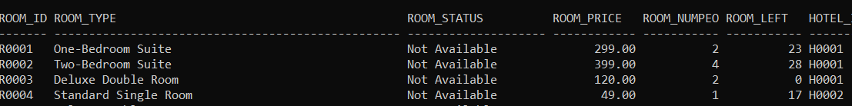

Explanation: Before this procedure is called, the room left of Room_ID ‘R0003’ is 0 and the room status is Not Available.

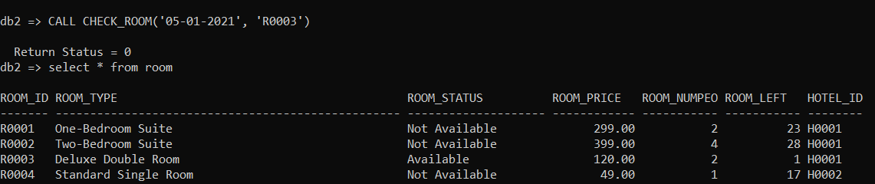

Explanation: After this procedure is called, the room left of Room_ID ‘R003’ become one and the room status changes to available.

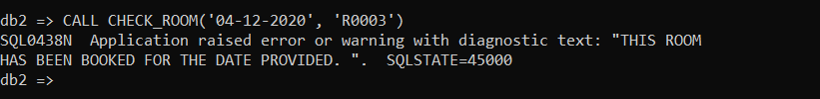

Explanation: If a customer enters the date which has been booked by others, an error message will show to customer.

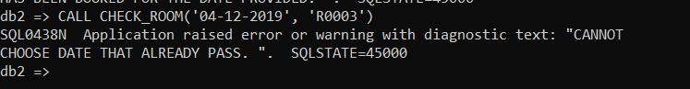

Explanation: If a customer enters a date that already passes, an error message will show to the customer..

**Guest Change Password**

CREATE PROCEDURE ChangePW(IN Email VARCHAR(50), OLD_P VARCHAR(50), NEW_P VARCHAR(50))

BEGIN

UPDATE GUEST

SET GUEST_PWORD = NEW_P

WHERE OLD_P = GUEST_PWORD AND GUEST_EMAIL = Email;

END

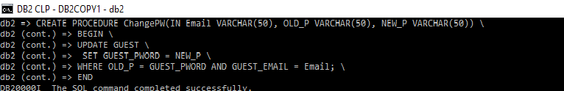

Explanation: The code of procedure for change GUEST password

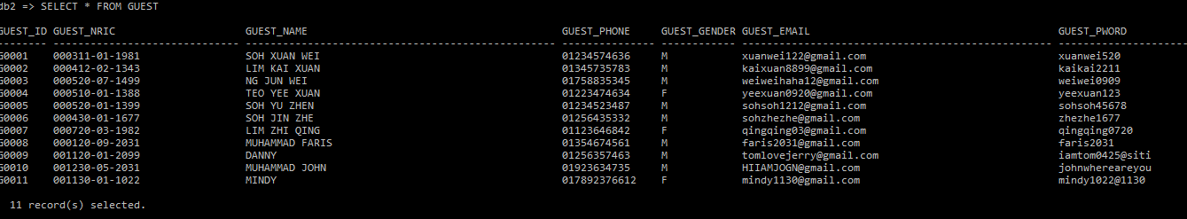

Explanation: Original password result of GUEST

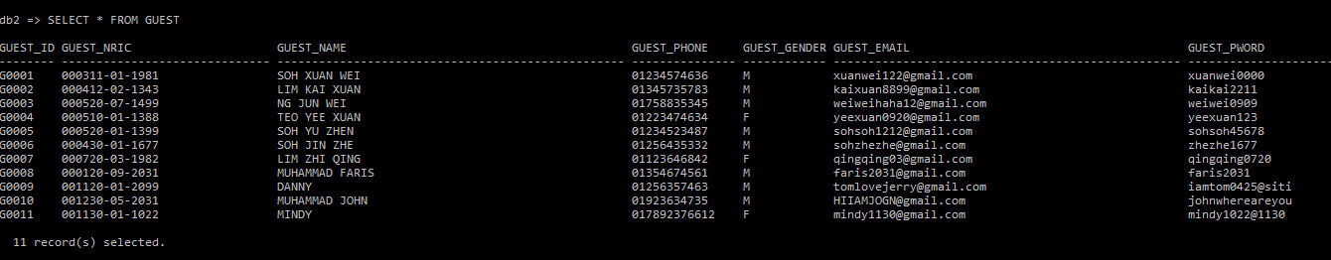

Explanation: The password of SOH XUAN WEI been changed after enter correct email and correct old password.The password change from xuanwei520 to xuanwei0000

To execute this procedure:

**CALL ChangePW('**[**xuanwei122@gmail.com**](mailto:xuanwei122@gmail.com)**', 'xuanwei520', 'xuanwei0000')**

**Procedure to get the promotional price when the date user key in is in promotional period**

CREATE PROCEDURE CHECK_PROMO (IN CHCK_IN DATE, CHCK_OUT DATE)

BEGIN

IF(CHCK_IN >= '08-31-2020' AND CHCK_OUT <= '09-01-2020')

THEN UPDATE BOOKINGSUMMARY SET TOTAL_PRICE = TOTAL_PRICE*0.70;

ELSEIF (CHCK_IN >= '01-25-2020' AND CHCK_OUT <= '01-26-2020')

THEN UPDATE BOOKINGSUMMARY SET TOTAL_PRICE = TOTAL_PRICE*0.70;

ELSEIF (CHCK_IN >= '05-23-2020' AND CHCK_OUT <= '05-24-2020')

THEN UPDATE BOOKINGSUMMARY SET TOTAL_PRICE = TOTAL_PRICE*0.65;

ELSEIF (CHCK_IN >= '12-31-2019' AND CHCK_OUT <='01-01-2020')

THEN UPDATE BOOKINGSUMMARY SET TOTAL_PRICE = TOTAL_PRICE*0.75;

ELSEIF (CHCK_IN >= '02-14-2020' AND CHCK_OUT <= '02-15-2020')

THEN UPDATE BOOKINGSUMMARY SET TOTAL_PRICE = TOTAL_PRICE*0.75;

ELSEIF (CHCK_IN >= '12-24-2020' AND CHCK_OUT <= '12-25-2020')

THEN UPDATE BOOKINGSUMMARY SET TOTAL_PRICE = TOTAL_PRICE*0.80;

ELSEIF (CHCK_IN >= '09-16-2020' AND CHCK_OUT <= '09-17-2020')

THEN UPDATE BOOKINGSUMMARY SET TOTAL_PRICE = TOTAL_PRICE*0.90;

ELSEIF (CHCK_IN >= '11-11-2020' AND CHCK_OUT <= '11-12-2020')

THEN UPDATE BOOKINGSUMMARY SET TOTAL_PRICE = TOTAL_PRICE*0.90;

ELSEIF (CHCK_IN >= '10-01-2020' AND CHCK_OUT <= '10-02-2020')

THEN UPDATE BOOKINGSUMMARY SET TOTAL_PRICE = TOTAL_PRICE*0.90; ELSEIF (CHCK_IN >= '10-27-2020' AND CHCK_OUT <= '10-28-2020') \

THEN UPDATE BOOKINGSUMMARY SET TOTAL_PRICE = TOTAL_PRICE*0.90;

END IF;

END

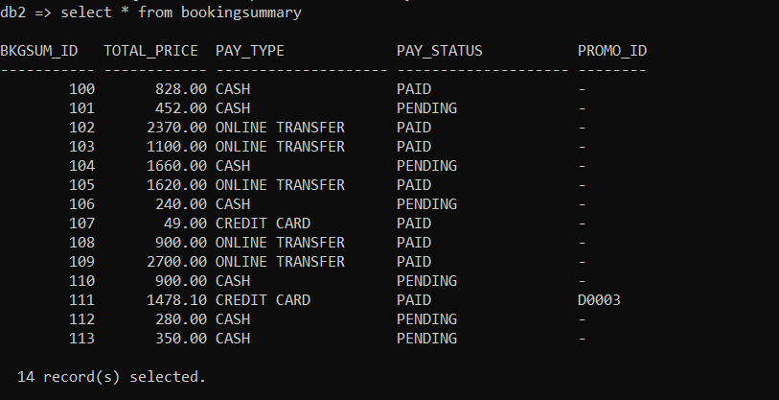

Explanation: Before the procedure be called

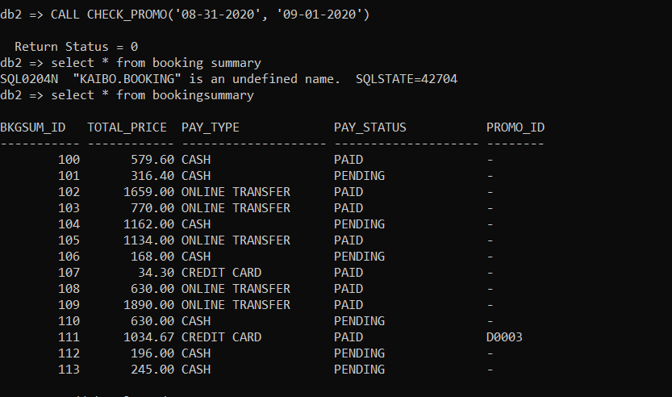

Explanation: After the procedure be called, the total price reduce due to promotion

To execute: **CALL CHECK_PROMO(**'**08-31-2020, 09-01-2020**'**)**

**FUNCTION**

**Room Filter**

CREATE FUNCTION RoomFilter(Budget DECIMAL(6,2), Rating DECIMAL(3,1), NUM_PEOPLE INTEGER, LOCATION VARCHAR(20))

RETURNS TABLE(HOTEL_NAME VARCHAR(50), HOTEL_RATING DECIMAL(3,1), HOTEL_STATE VARCHAR(20), ROOM_TYPE VARCHAR(50), ROOM_NUMPEO INTEGER, ROOM_PRICE DECIMAL(10,2))

LANGUAGE SQL

READS SQL DATA

NO EXTERNAL ACTION

DETERMINISTIC

RETURN

SELECT HOTEL_NAME, HOTEL_RATING, HOTEL_STATE, ROOM_TYPE, ROOM_NUMPEO, ROOM_PRICE

FROM HOTEL, ROOM

WHERE HOTEL.HOTEL_ID = ROOM.HOTEL_ID AND ROOM_PRICE <= Budget AND HOTEL_RATING >= Rating AND ROOM_NUMPEO >= NUM_PEOPLE AND HOTEL_STATE = LOCATION

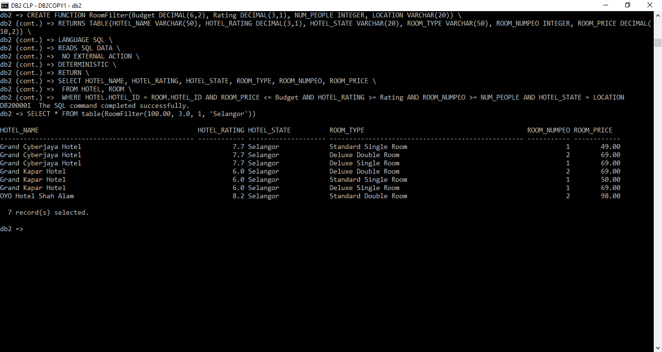

Explanation: The function filter the room by the budget, hotel rating, number of people suitable for the room and location of hotel which are inserted by the user.

To execute: SELECT * FROM table(RoomFilter(100.00, 3.0,1, 'Selangor'))

**Show details of specific type of room for each hotel**

CREATE FUNCTION RoomType(Type VARCHAR(50))

RETURNS TABLE(HOTEL_NAME VARCHAR(50), ROOM_TYPE VARCHAR(50), ROOM_NUMPEO INTEGER, ROOM_LEFT INTEGER, ROOM_PRICE DECIMAL(10,2))

LANGUAGE SQL

READS SQL DATA

NO EXTERNAL ACTION

DETERMINISTIC

RETURN

SELECT HOTEL_NAME, ROOM_TYPE, ROOM_NUMPEO, ROOM_LEFT, ROOM_PRICE

FROM HOTEL, ROOM

WHERE HOTEL.HOTEL_ID = ROOM.HOTEL_ID AND ROOM_TYPE = Type AND ROOM_LEFT != 0

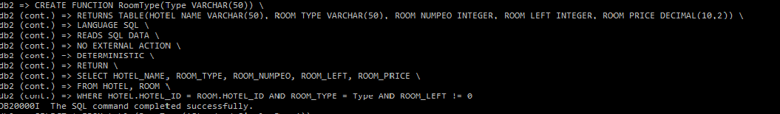

Explanation: Code of function that perform details of specific type of room of each hotel

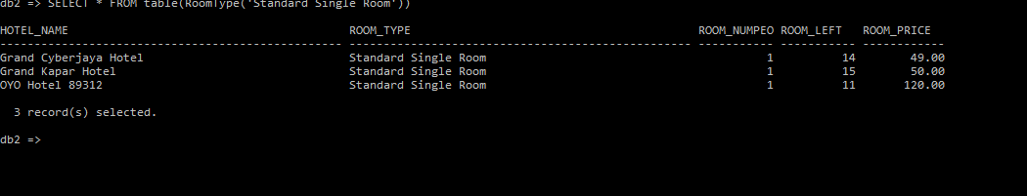

Explanation: The result shows the details of the Standard Single Room of each hotel, if the hotel does not have that kind of room or room is not available then will not show in the result.

To execute: SELECT * FROM table(RoomType('Standard Single Room'))

## **VIEW**

**Quick check for Each Hotel’s Room details**

CREATE VIEW ViewHotel AS

SELECT HOTEL_NAME, ROOM_TYPE, ROOM_PRICE, ROOM_LEFT

FROM HOTEL, ROOM

WHERE HOTEL.HOTEL_ID = ROOM.HOTEL_ID

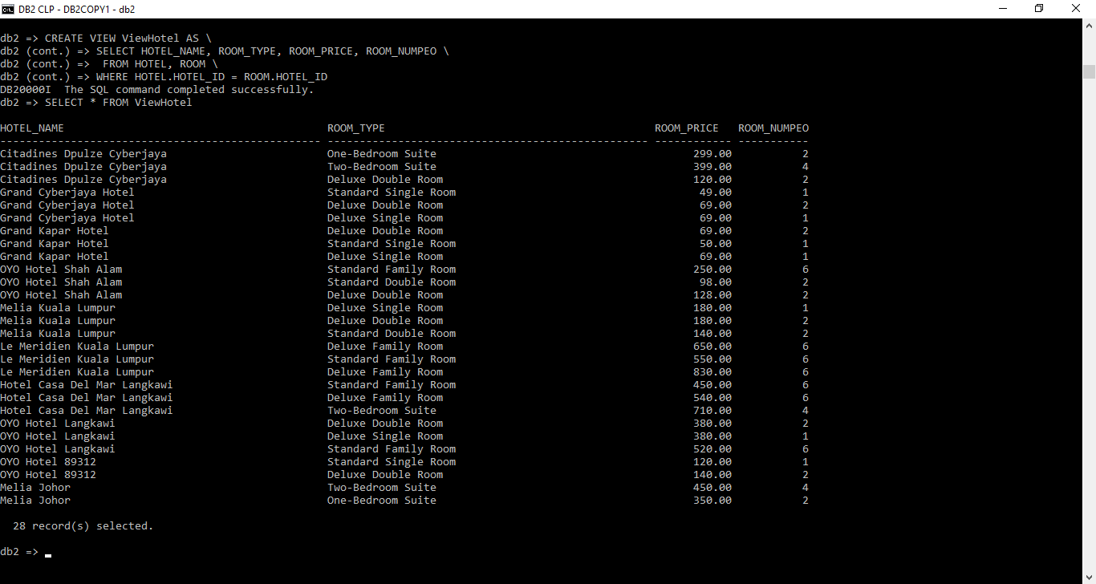

Explanation : Check the room type, price and room left of each hotel by using view.

## 

## **SUBQUERIES / NESTED QUERIES**

**The hotel with highest rating**

SELECT HOTEL_NAME, HOTEL_RATING

FROM HOTEL

WHERE HOTEL_RATING = (SELECT MAX(HOTEL_RATING) FROM HOTEL)

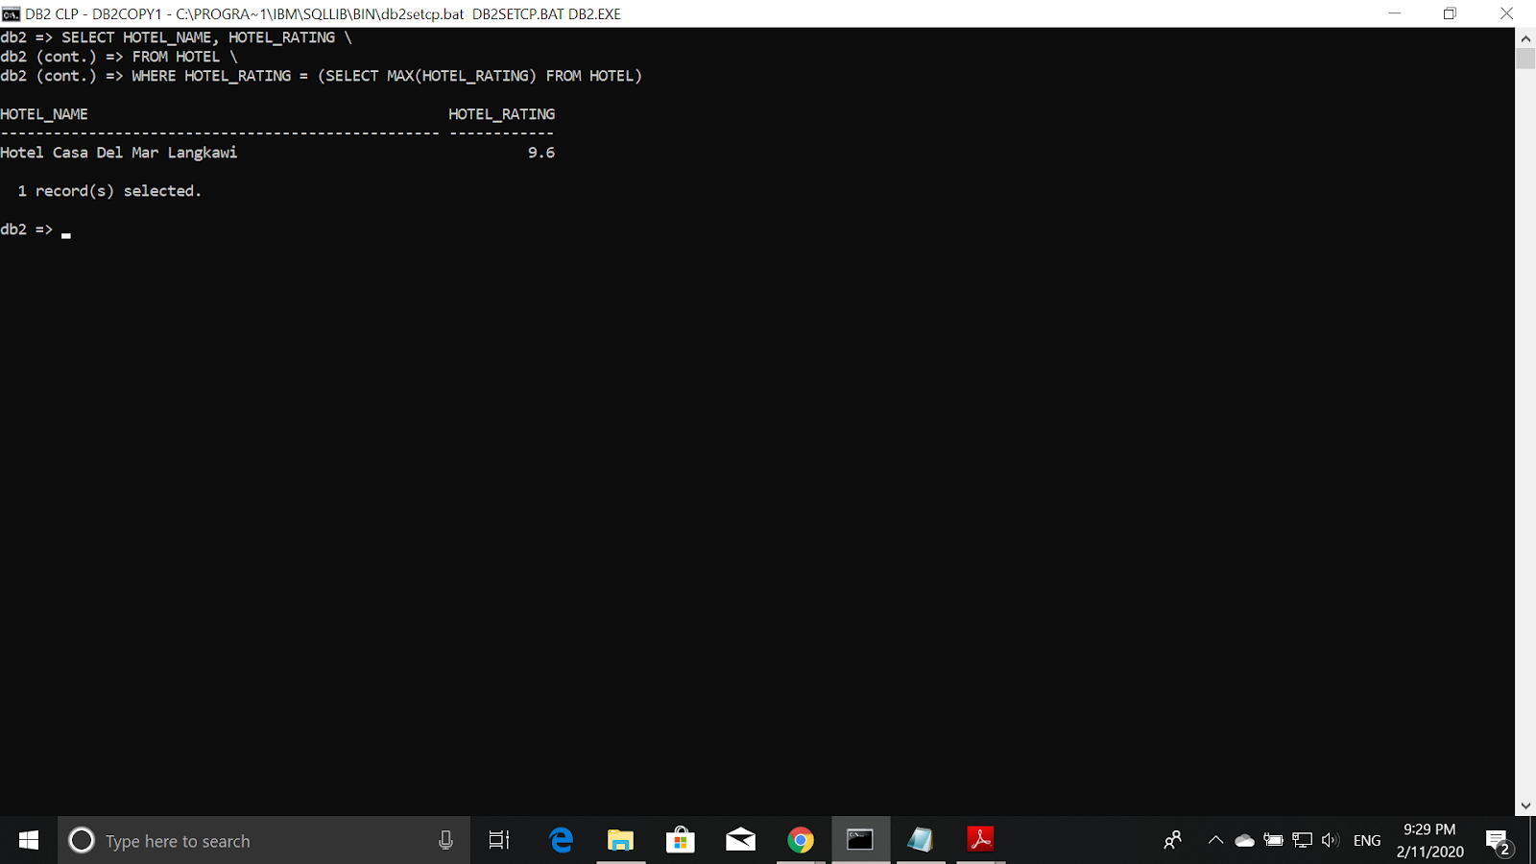

**The guest who made the most payment in the system**

SELECT DISTINCT GUEST_NAME, TOTAL_PRICE

FROM GUEST, BOOKINGDETAILS, BOOKINGSUMMARY

WHERE GUEST.GUEST_ID = BOOKINGDETAILS.GUEST_ID AND

BOOKINGDETAILS.BKGSUM_ID = BOOKINGSUMMARY.BKGSUM_ID AND

TOTAL_PRICE = (SELECT MAX(TOTAL_PRICE) FROM BOOKINGSUMMARY

WHERE PAY_STATUS = 'PAID')

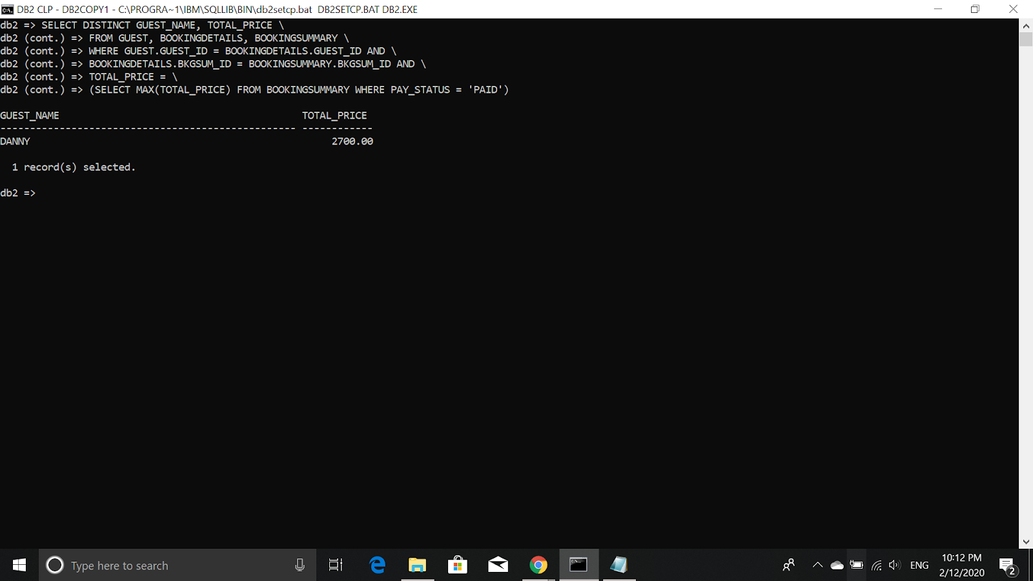

**The Lowest price of hotel’s room**

SELECT HOTEL_NAME, ROOM_TYPE, ROOM_PRICE

FROM ROOM, HOTEL

WHERE ROOM.HOTEL_ID = HOTEL.HOTEL_ID AND ROOM_PRICE = (SELECT MIN(ROOM_PRICE) FROM ROOM)

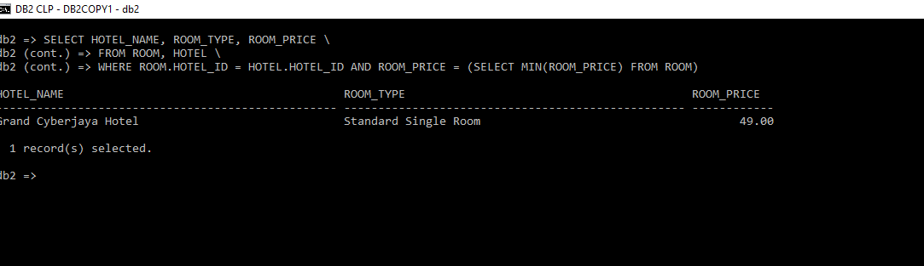

## 

## **OTHERS**

**LIMIT**

**The Top Five Room Types Most Booked by the Guest**

SELECT ROOM_TYPE, COUNT(BOOKINGDETAILS.ROOM_ID) AS TOTAL_BOOKING

FROM ROOM, BOOKINGDETAILS WHERE ROOM.ROOM_ID = BOOKINGDETAILS.ROOM_ID

GROUP BY ROOM_TYPE ORDER BY TOTAL_BOOKING DESC LIMIT 5

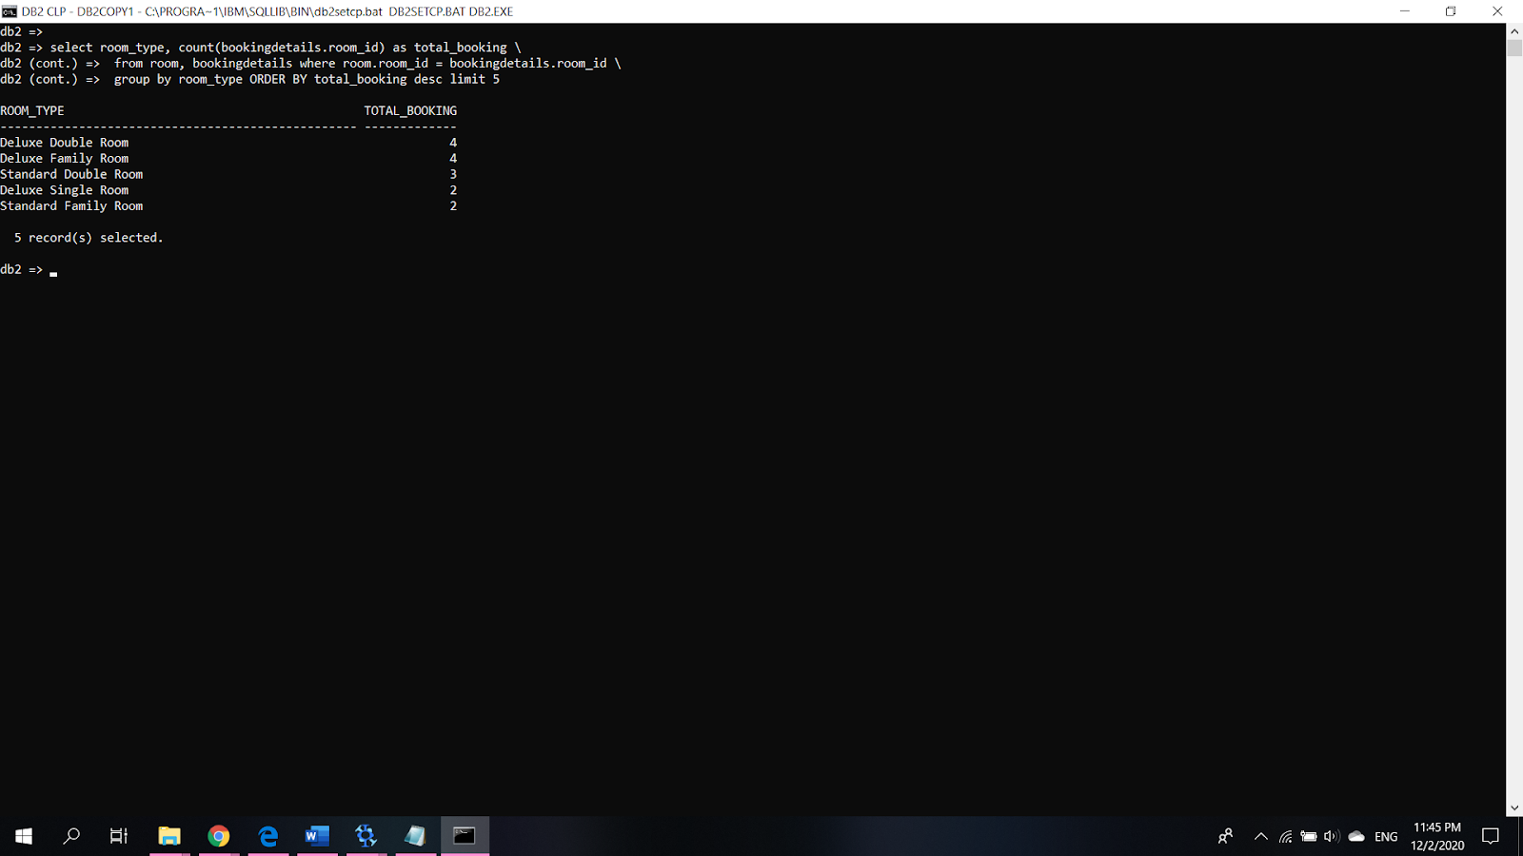

**FETCH**

Display the top 3 highest total price that the guests still hasn’t paid

SELECT DISTINCT BOOKINGSUMMARY.BKGSUM_ID, GUEST_NAME,PAY_TYPE, TOTAL_PRICE

FROM GUEST, BOOKINGSUMMARY, BOOKINGDETAILS WHERE

BOOKINGSUMMARY.BKGSUM_ID = BOOKINGDETAILS.BKGSUM_ID AND GUEST.GUEST_ID = BOOKINGDETAILS.GUEST_ID

AND PAY_STATUS = 'PENDING' ORDER

BY TOTAL_PRICE DESC FETCH FIRST 3 ROWS ONLY

